Angular2

### What are some of the advantages of Angular over other frameworks?

• **Features that are provided out of the box -** Angular provides a number of built-in features like,routing, state management, rxjs library and http servicesstraight out of the box. This means that one does not need tolook for the above stated features separately. They are allprovided with angular.

• **Declarative UI -**Angular uses HTML to render the UI of an application. HTML isa declarative language and is much easier to use than JavaScript.

• **Long-term Google support -**Google announced Long-term support for Angular. This means that Google plans to stick with Angular and further scale up its ecosystem.

**Why to use TypeScript?**

Angular2

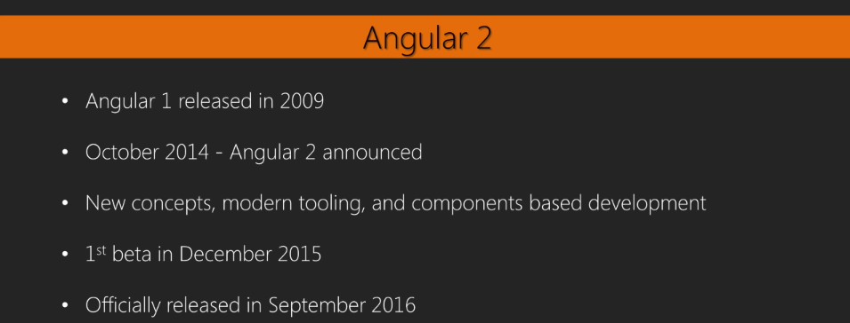

**Why to use TypeScript?**

**🡪If we have to write big Javascript Application and don’t follow the patterns such as revealing pattern,The code becomes Messy.**

**1.it becomes less maintainable 2.Less reusable**

**To learn Typescript refer Typescriptlang.org**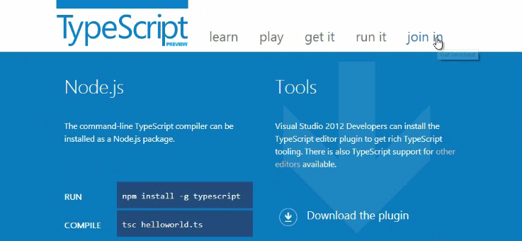

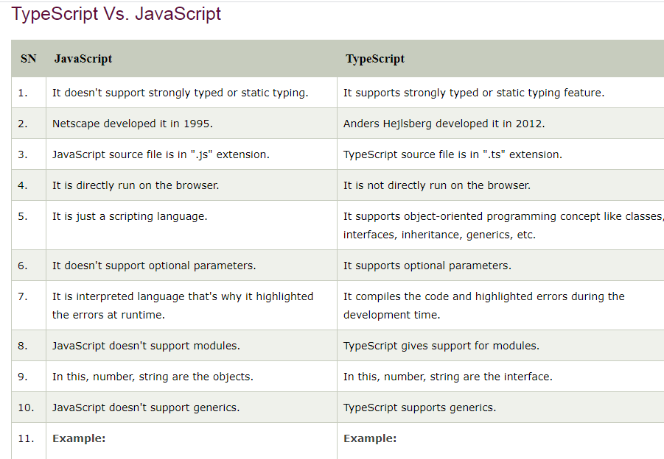

It shows tsc is not a recognized then install type script again

(Or_)

[tsc.ps1 cannot be loaded because running scripts is disabled on this system](https://stackoverflow.com/questions/58796490/tsc-ps1-cannot-be-loaded-because-running-scripts-is-disabled-on-this-system)

**to solve that**

open Commandform : **windows + R**

Type : **Powershell**

Then type : **set-executionpolicy remotesigned**

**syntax:tsc filename.ts**

**tsc helloworld.ts**

**typescript produces a javascript file we have to execute this**

**syntax:node filename.js**

**ex helloworld.js**

**helloworld**

**🡪If we have to write big Javascript Application and don’t follow the patterns such as revealing pattern,The code becomes Messy.**

**1.it becomes less maintainable 2.Less reusable**

**How single page app works with angular**

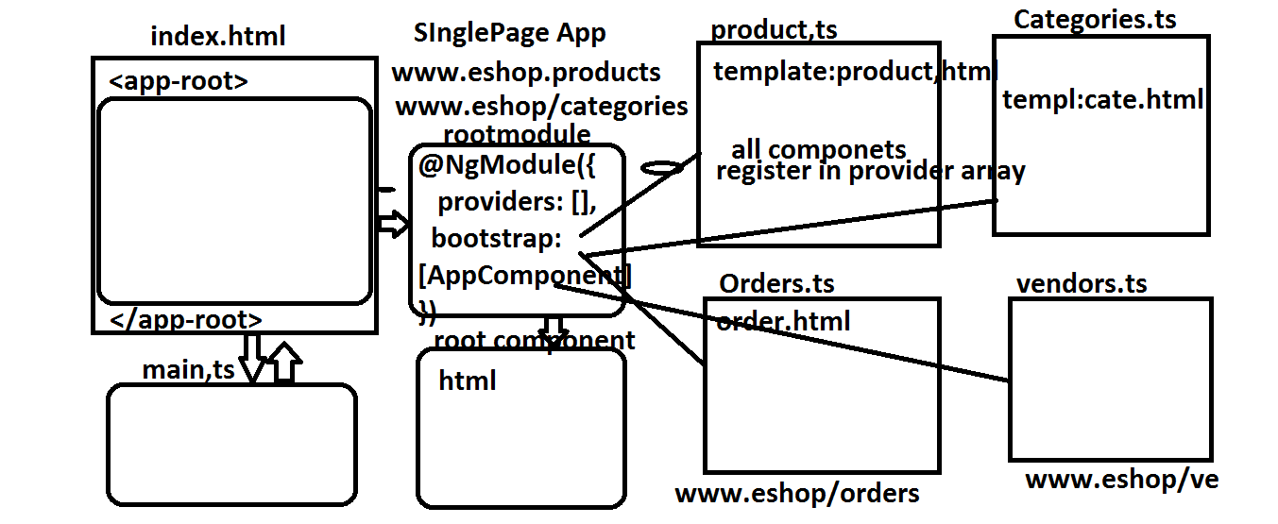

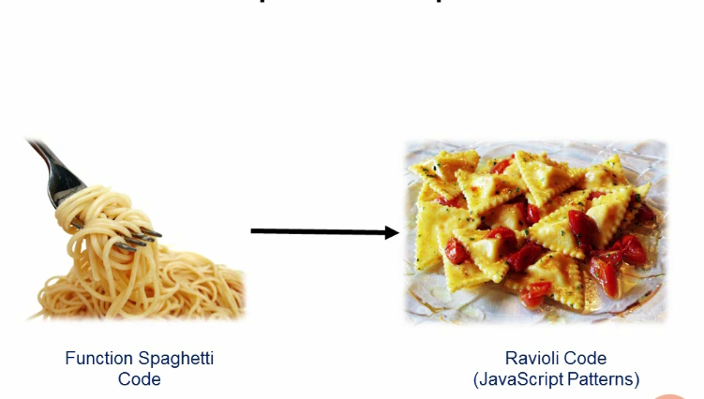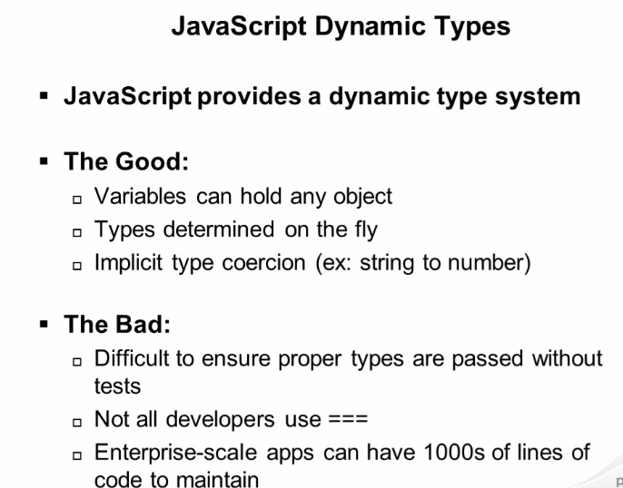

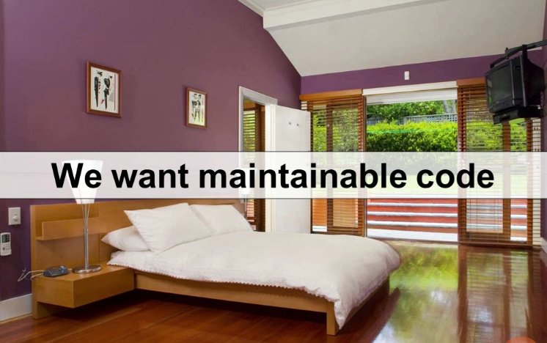

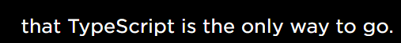

**Angular1 so Implemented MVC Pattern**

**In Angular1 Template is the kind of Control.Template identify the one more Controller in Controller Section of Our Page.**

**In angular2 Templates or view are associated one to one.suppose navigation is one Component.footer of the page is one component and sidebar is another Component.**

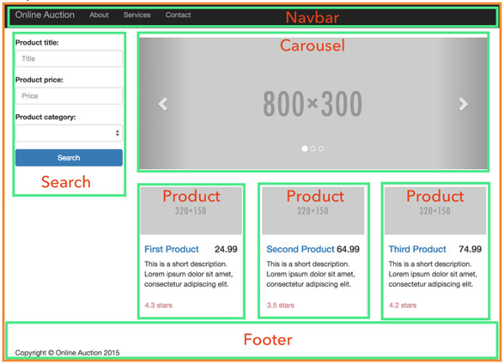

Angular 2 is not an MVC framework, but rather a component-based framework. In Angular 2 an application is a tree of loosely coupled components.

Chapter01 how angular works?

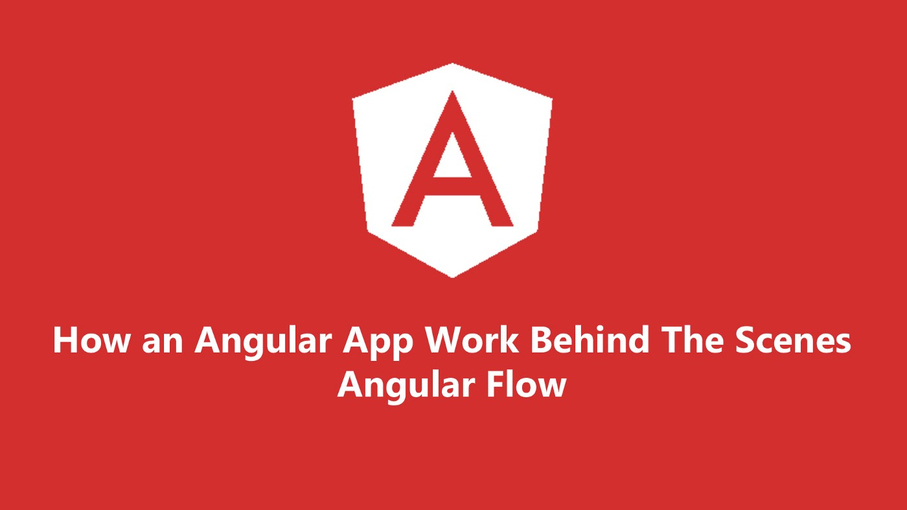

* Angular started with main.ts.
* Then we bootstrap an angular application and we pass app.module.ts as an argument. In app.module.ts we tell angular: *"There is the app component which you should know when you try to start yourself".*
* And angular now analyze this app component, reading the set up we pass there and there is *SELECTOR app-root*.
* Now, angular is enable to handle *app-root* in the index.html and knows rules for the *SELECTOR*.
* *SELECTOR* should insert the app components and have some HTML code - a template attached to him - html component.
* This is how Angular application starts.
* 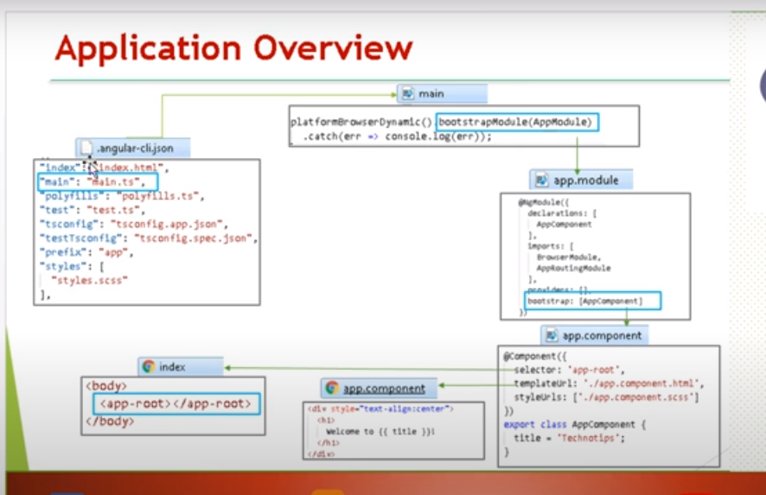

**Angualr2 ANATOMY**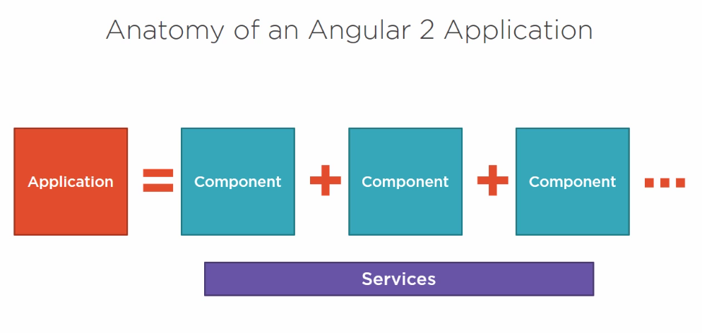

**What is Component?** COMPONENT IS A View DEFINED WITH **Template** and its Assocaited Code is Defined with a **class** and additional info is defined in metadata.Metadata we use to tell angular about the object we build .METADATA Links the TEMPLATE To Component. 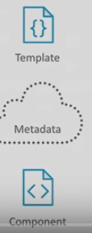

Each Component is Comprised of a Template, which is the Html For the User Interface for View Fragment.

2. A class will be associated to view.the class contains .🡪**Properties** : data elements or properties are used in view and methods which are performs actions for the view such as responding to button click.🡪a Component also will have **Metadata-🡪Provides additional info about the Component with the metadata angular identifies the class as an Component**

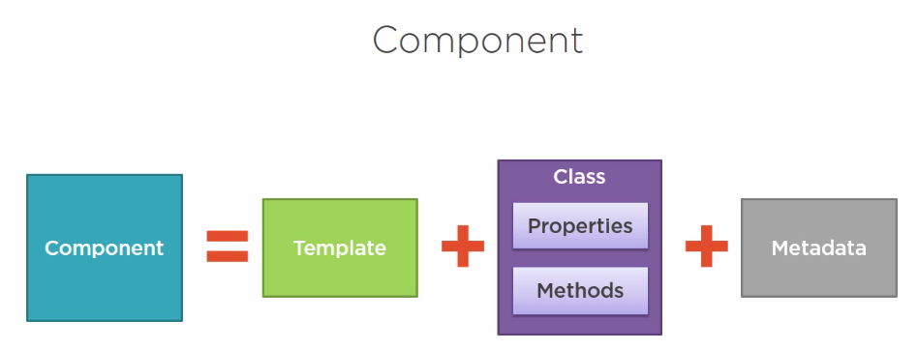

**Q)After building these Components how do we pull them into Applications?**

**ANS:By Defining Angular Modules.**

**AM Helps us to Organize our Application into Blocks of Code having some functionality**

**🡪Every Angualar application must have at least one Module called the Root Angular Module.and application can have any number of Modules.including Feature Modules that will Consolidate the Components.**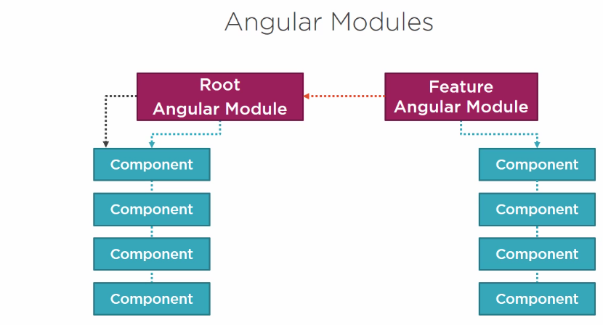

**The router see the url and load the component in the tree.suppose if the user visits another url then again A tree is loaded with corresponding component with its subcomponents if the page is more complex one.this repeats for every route.when we create Componets we create 1.PIPE 2.DIRECTIVE. 3.SERVICE We have to register them in each component individually.**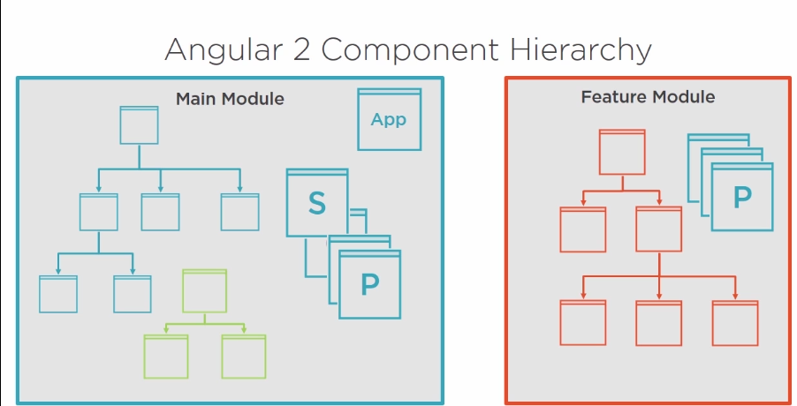

DIRECTIVEE

**All these are available only in that Component.if we want make them available in other components we have to use “SERVICE”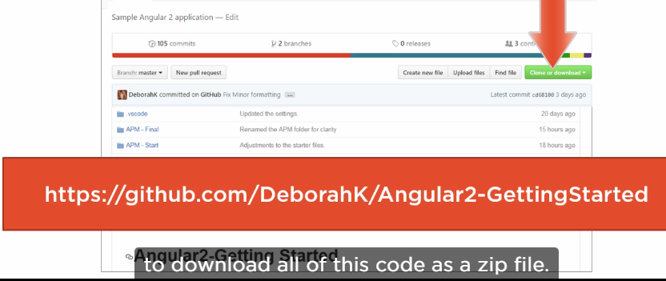**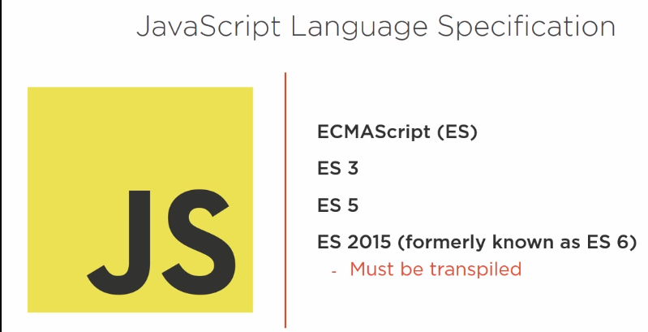

ES2015 is not supported by many browsers so need trans piling means the code written in Javascript must be compiled to Javascript using transcompiler and Typescript can do that 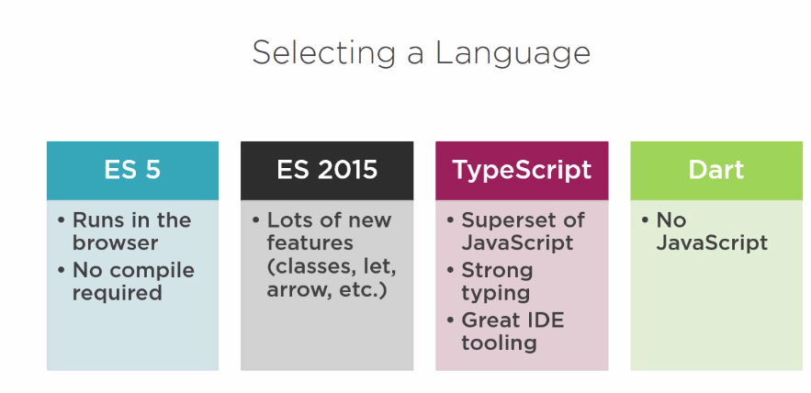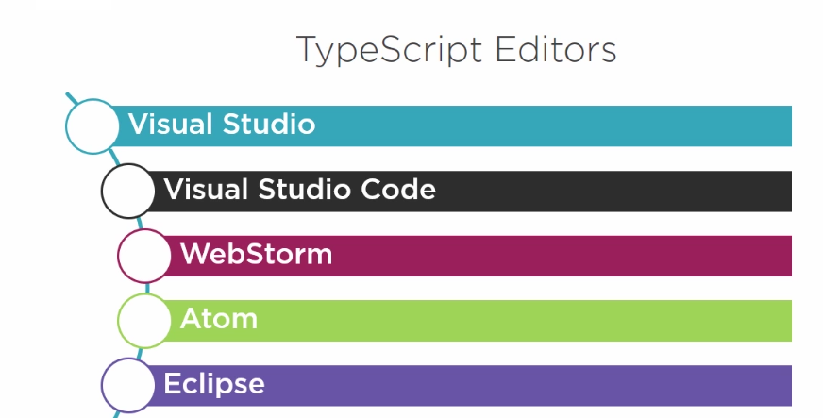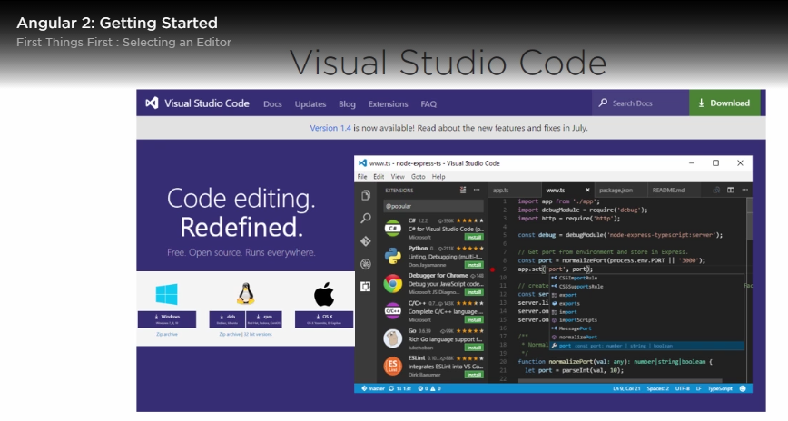 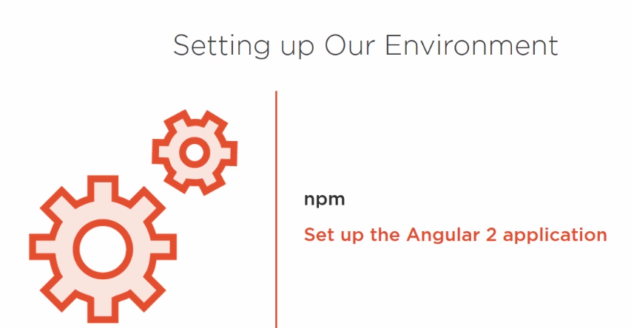

**Step1:Install node from nodejs..org**

1.Npm Means Node Package manager for JavaScript and it is a commandline utility that intereacts with Open Source Projects. Using Npm We Can Install Packages and Libraries along with their Dependencies.

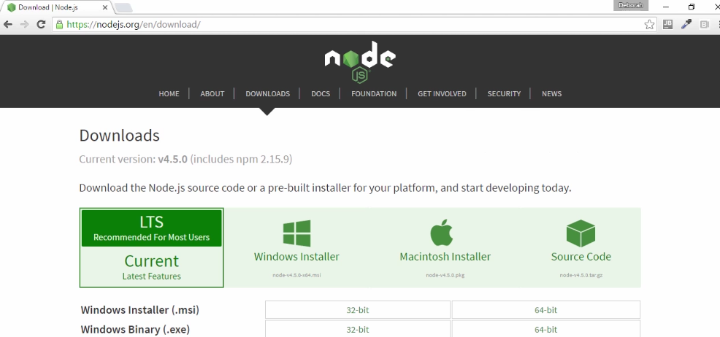

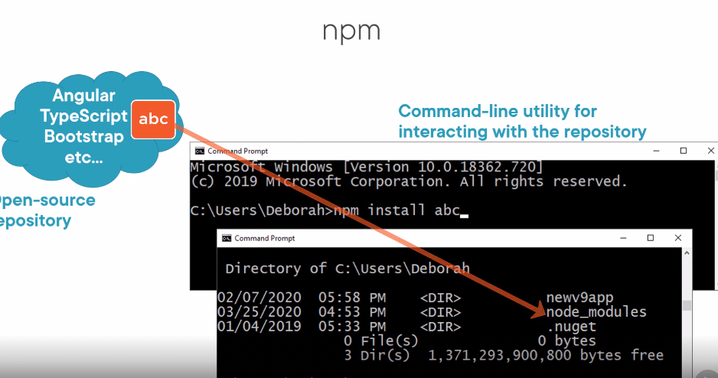

**Step2:Setting up angular2 is laborious**

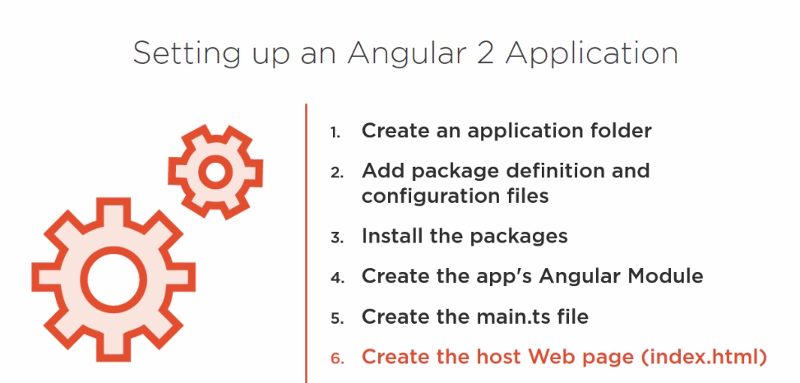

**This is laborious so we have some readymade other options. download the result of work done with manually form github refer secondlink in slide**

**Angular CLI is a Command Line tool to generate SetUp Files and boilerplate Code for angular including scaffolding and unit and end to end tests**

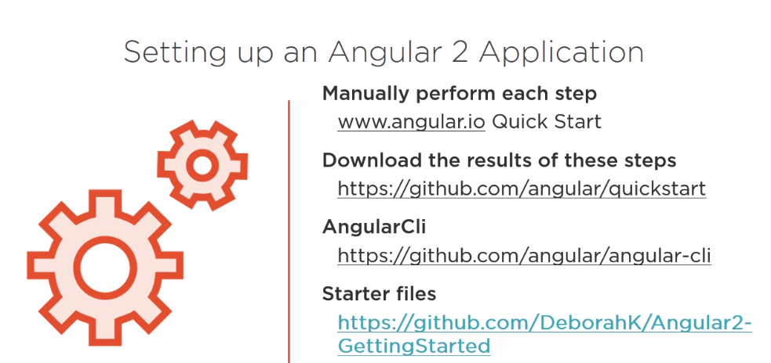

## [Essential VSCode Extensions for Angular Developers](https://morioh.com/p/0e54a8cff696)

In this post, I’m going to list my top favorite Visual Studio Code (VSCode) extensions for building Angular applications. If you know a great extension that is missing here, please let us know using the comment box below the post.

## Installing an Extension

If you know how to install an extension in VSCode, feel free to skip this section. Otherwise, launch VSCode, and open the **Extensions** tab from the left side bar. Here, you can see the list of installed extensions. You can also search for other extensions. Once you find an extension, simply click the **Install** button. Then, reload VSCode and you’re good to go.

## [TypeScript Hero](https://marketplace.visualstudio.com/items?itemName=rbbit.typescript-hero)

This is by far my absolute favorite extension! You no longer have to manually import types in TypeScript. TypeScript Hero automatically imports the types for you as you write code. When pasting some code from somewhere else, you can also add all the missing import statements in one go!

Another useful feature of this extension is that it allows you to sort and remove the unused import statements. You also get code completion and several other useful features. Highly recommended!

## [Angular Language Service](https://marketplace.visualstudio.com/items?itemName=Angular.ng-template)

This extension provides a rich editing experience for Angular templates. Imagine you have a field in your component as follows:

Install visual studio keymap extension

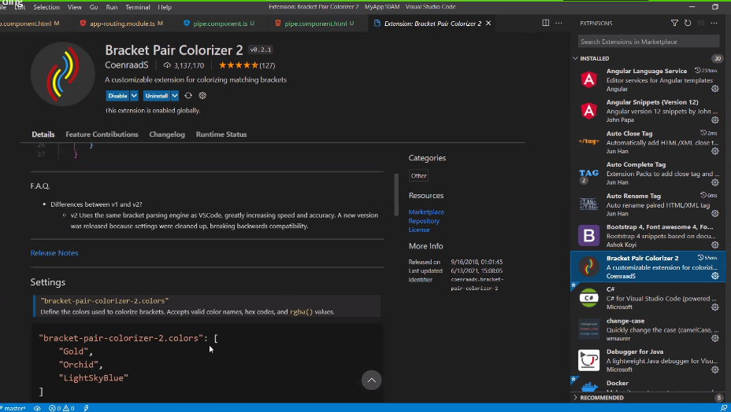

course = {

title: 'The Complete Angular Course',

author: {

name: 'Mosh Hamedani'

}

}

With this extension, you’ll get auto-completion in your HTML templates:



## [Bracket Pair Colorizer](https://marketplace.visualstudio.com/items?itemName=CoenraadS.bracket-pair-colorizer)

This extension allows matching brackets to be identified with colors.



## [Move TS](https://marketplace.visualstudio.com/items?itemName=stringham.move-ts)

As your application grows, you may want to break it down into smaller and more maintainable modules. You’ll have to move files and folders around. But what happens to all your import statements? They break! So, that’s what this extension is for. With Move TS extension, you can simply move files/folders around and this extension will automatically update your import statements.

## [Material Icon Theme](https://marketplace.visualstudio.com/items?itemName=PKief.material-icon-theme)

Do you like to have pretty icons in the project explorer? Install this extension!



## [Angular TypeScript Snippets](https://marketplace.visualstudio.com/items?itemName=johnpapa.Angular2)

Another useful extension developed by John Papa that boosts your productivity when building Angular applications. It gives you a bunch of code snippets that allow you to quickly generate code. There are snippets for creating a component, service, directive, etc. You may argue that now we can easily create these artifacts using Angular CLI and that is absolutely right. However, this extension gives you some useful HTML snippets as well:



You can find the complete list of snippets provided by this extension [here](https://marketplace.visualstudio.com/items?itemName=johnpapa.Angular2).

#angular #web-development #vscode

Open viusalstudiocode and check what files we got after opening the folder

Click on terminal -🡪new terminal

**Getting started with angular creating firt project**

**step:1 install node from nodejs.org**

**install latest version**

**check installed node version**

**node -v**

**create a folder and open in vscode**

**click on new terminal at top**

**install angular**

**npm install -g @angular/cli**

**to check version of angular installed**

**ng –version**

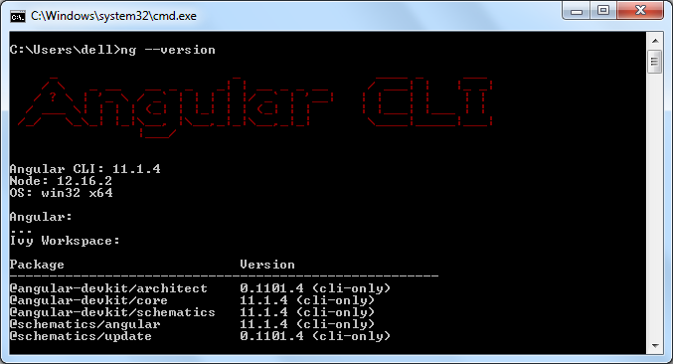

Angular CLI use Package.json in your application to install all the necessary libraries and packages for your application, including the required Angular framework libraries.

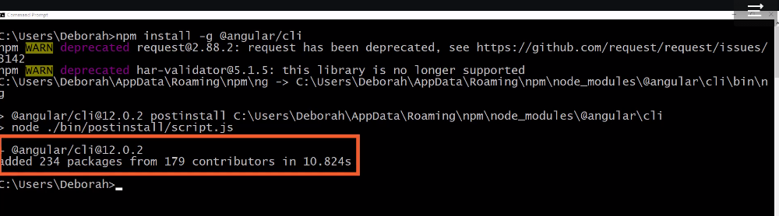

**step 2: create new project**

**to create a project we have write**

**🡪ng new projectname**

**go into the project folder**

**🡪cd newproject**

**step3: run the project**

**🡺ng serve --open**

**if we want to stop angular server**

**ctrl+c**

# Create Angular Application

Here you will learn to create an Angular 2 (valid in the Angular 11 too) application using Angular CLI.

Angular CLI helps us to set up a workspace and an initial application quickly, which includes necessary NPM libraries and other dependencies for the application.

To create an initial application, navigate to the folder where you want to create an application, and execute the

ng new <project name> command in the terminal/command window.

The following creates a new angular application named "FirstAngularApp" in the AngularApps folder.

D:\AngularApps> ng new FirstAngularApp

The ng new command prompts you for information about features to include in the initial app project. You can accept the defaults by pressing an Enter key, as shown below.

[](https://www.tutorialsteacher.com/Content/images/angular/create-angular-app.gif)Generate Angular App using Angular CLI

The above command may take 2-3 minutes to create a project and install necessary libraries. To open this project in VS Code, navigate to the project folder in the terminal/command window and type code ..

D:\AngularApps\FirstAngularApp\>code .

Your new project in VS Code will look like below.

[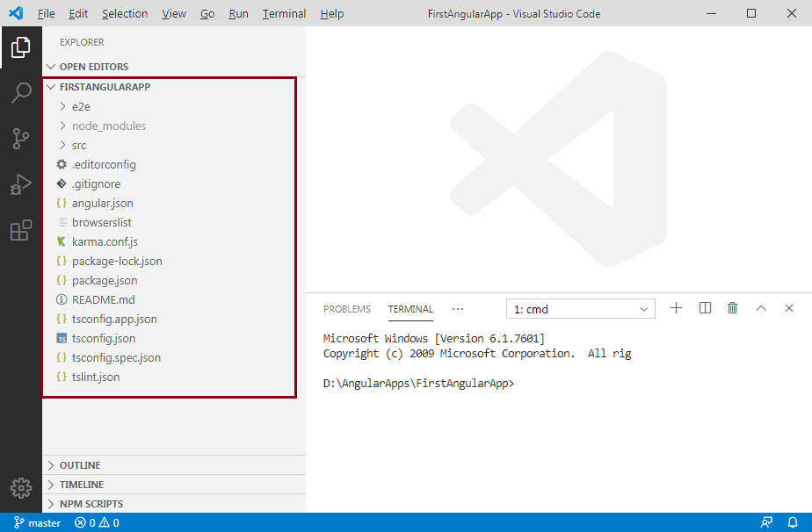](https://www.tutorialsteacher.com/Content/images/angular/angular-project.png)Angular Project in VS Code

The left pane in VS Code shows the files and folders created by Angular CLI. Learn about the Angular project folder structure [here](https://angular.io/guide/file-structure).

## Run Angular Application

To run an Angular application in the browser, you first need to build it.

You can build and run applications either using Angular CLI command or NPM command. You can use the terminal/command window to execute these commands. However, if you are using VS Code then you can execute commands from its terminal.

Use Angular CLI command ng serve -o to build an application. The -o indicates to open it automatically in the default browser.

Use NPM command npm start to build an application. Internally, it uses ng serve command only. Open a browser and navigate to http://localhost:4200 to see the application home page. The http://localhost:4200 is the default URL of an Angular application created using Angular CLI.

Open the terminal in VS Code from menu Terminal -> New Terminal, and type ng serve -o command and press enter, as shown below.

[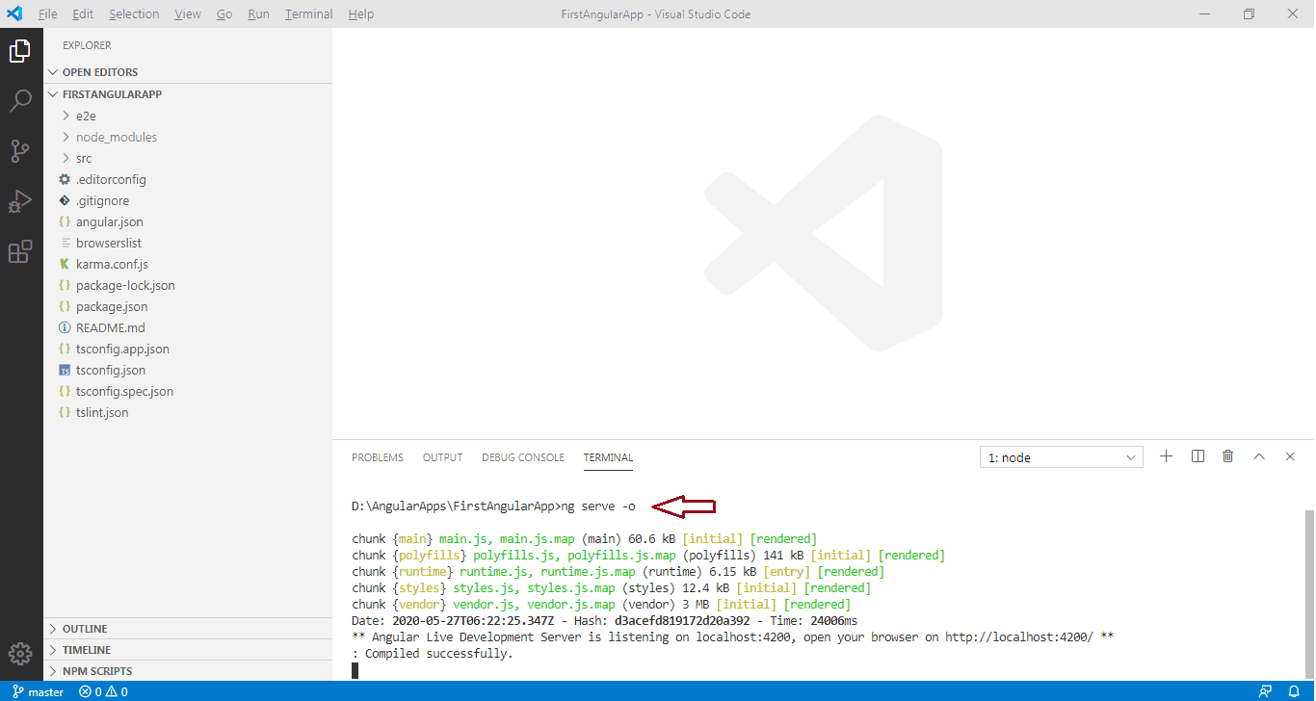](https://www.tutorialsteacher.com/Content/images/angular/run-angular-app.png)

The ng serve command builds the app, starts the development server, watches the source files, and rebuilds the app as you make changes to those files. It will open your Angular application in the default browser, as shown below.

[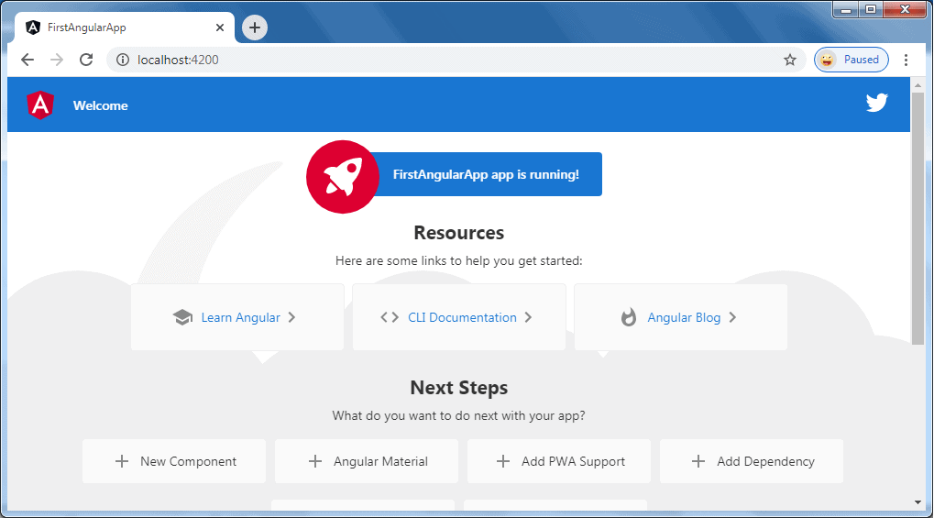](https://www.tutorialsteacher.com/Content/images/angular/angular-app.png)

The ng serve command keep watching source files, so if you make any changes in any file of the project, it will rebuild it and refresh the browser automatically to reflect the changes.

To stop the automatic build process, press Ctrl + c in the terminal of VS Code.

Thus, you can create a workspace and an initial Angular project and run it using VS Code.

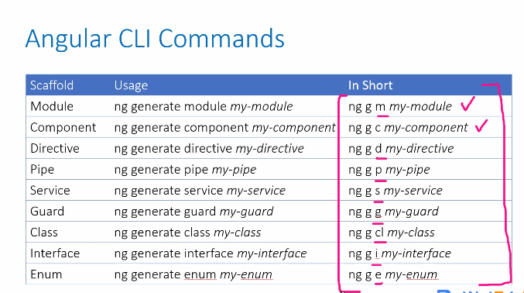

We need to tell Angular to load our root component through a process that is called bootstrapping

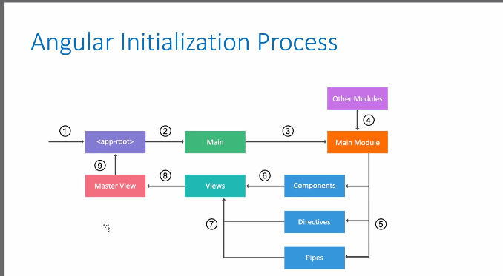

### Bootstrapping Our App Component

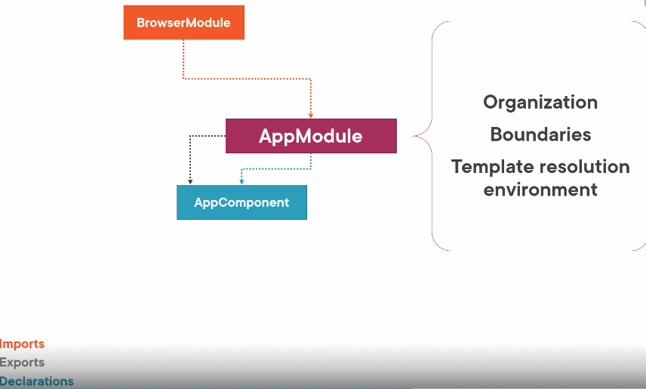

We first set up the index.html file to host our application.

Then we define our root Angular module to bootstrap our root component. Let's look at both of these steps.

Client‑side web applications often work like this. A user accesses of specific URL. The server associated with that URL is located and sent a request.

The server responds by returning its default web page, index.html. The browser receives and processes that index.html file. For an Angular application, the index.html file contains script tags referencing the application files that were transpiled and bundled into several JavaScript files. These application files are then downloaded to and processed by the browser, and the application's main page appears.

The index.html file contains that main page for the application. This index.html file is often the one true web page of the application. Hence, an application is often called a single‑page application or SPA. But don't worry. It will look to the user like we have lots of pages, as we saw in the demo at the beginning of this course. What we do is insert bits of HTML into the one HTML page to find an index.html.

Let's see how that works. Here again is our app component just shifted to the right.

Recall that the selector is the name of the component when we use it as a directive in HTML, and the template defines the HTML that we want to display. 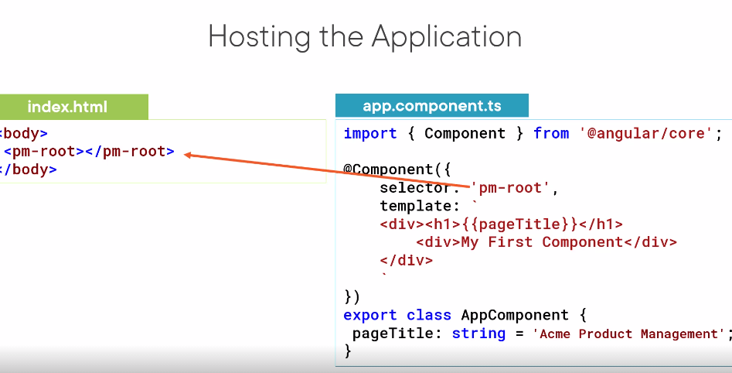 So in the index.html file, we simply add the selector where we want our template displayed. Here in the template, we call this a directive. A directive is basically a custom element

. As soon as the loading is complete, the HTML defined in the component template is inserted between the selector element tags and appears on the page.

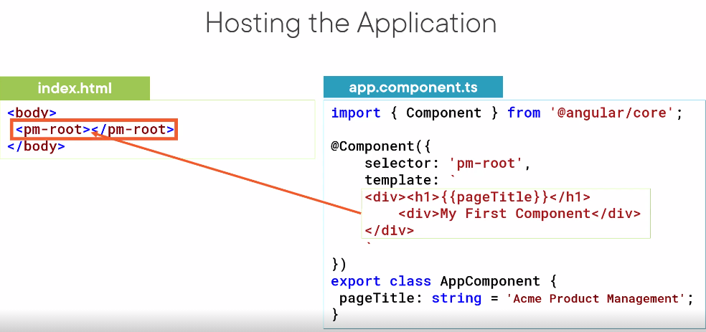

But how does the Angular compiler know about this custom HTML element? It looks in an Angular module. Angular modules help us organize our application into cohesive blocks of functionality and provide boundaries within our application. They also provide a template resolution environment. What does that mean?

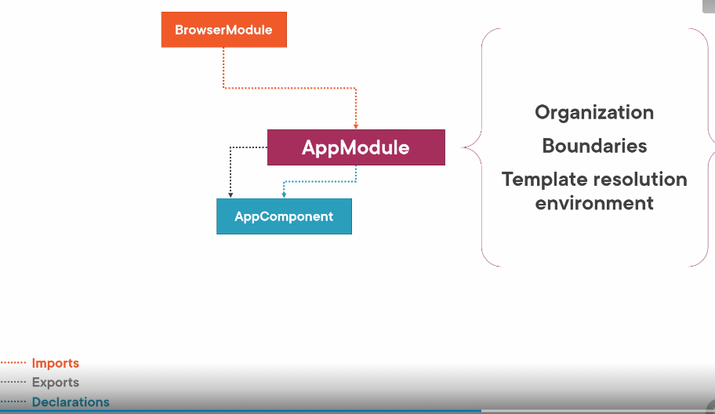

When the Angular compiler sees a directive and a template, it looks to the Angular module for the definition. So we declare the AppComponent in an Angular module so the compiler can find it. We also use the module to bootstrap our startup component, which is our AppComponent. And we want our application to work correctly in the browser, so we add Angular's BrowserModule to our Angular module's imports. Okay, pictures are nice,

but what does that look like in code? Here is our application's root Angular module. As with most everything in Angular, we define an Angular module using a class. We identify the class as an Angular module by attaching the NgModule decorator and passing in metadata, defining the details of this Angular module. For the NgModule decorator, the properties are arrays. In the declarations array, we define which of our components belong to this module. By convention, our root application component, AppComponent, belongs to the applications root Angular module, AppModule.

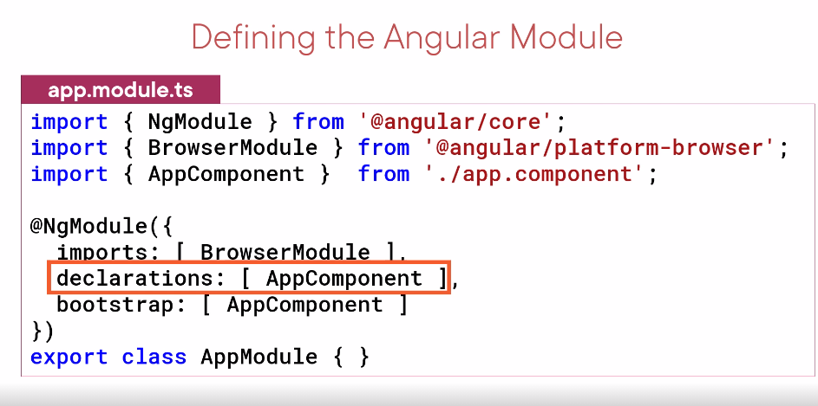

So we declare it here. We can add other components here as well.. For now, all of our components will be declared here.

**In the import array,**

we define the external modules that we want to have available to all of the components that belong to this Angular module.

External modules could be modules provided by Angular, a third party, or our own Angular modules.

Here we **import BrowserModule,** which every browser application must import. BrowserModule registers important application service providers, such as error handling.

The bootstrap array defines the startup component of the application, which is our AppComponent. The startup component should contain the selector we use in the index.html file, which, in this case, it does. Now let's check it out in the sample application.

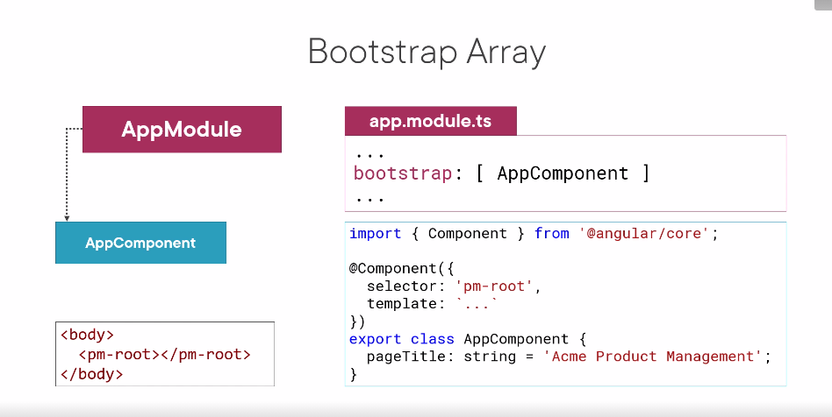 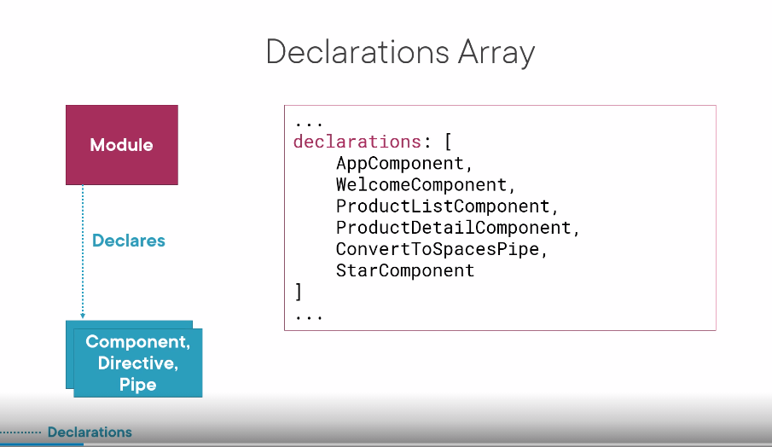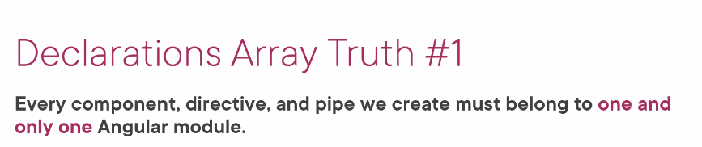



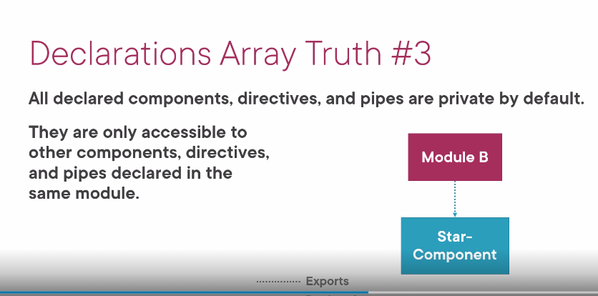

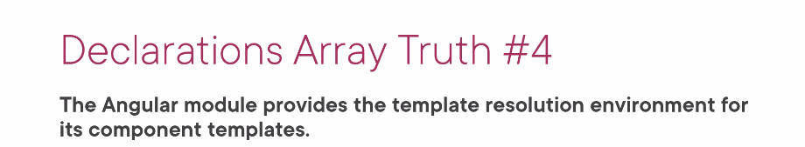

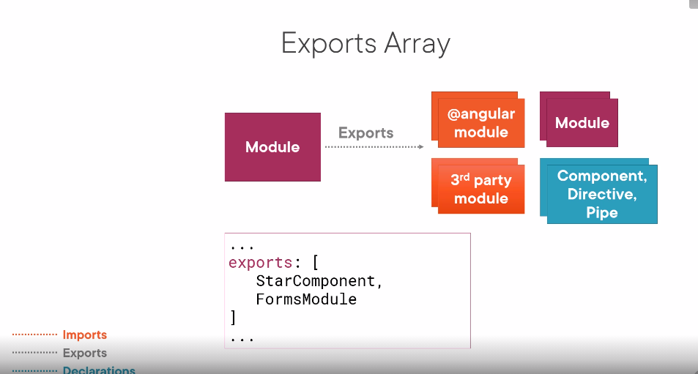

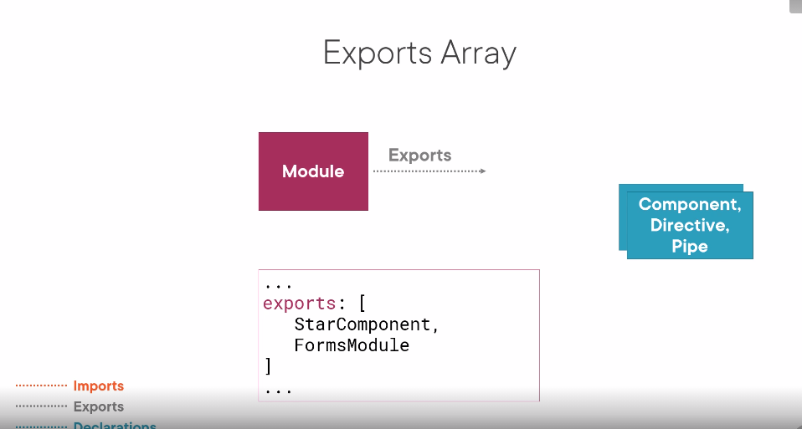

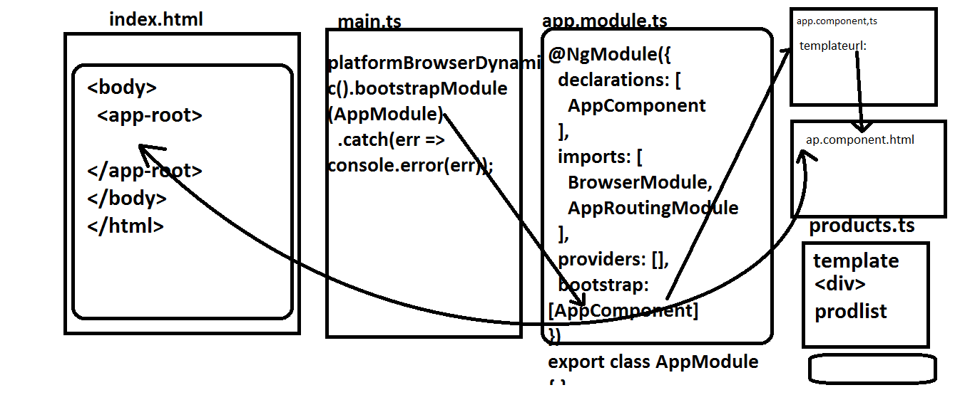

To write a component we use **class** keyword.To make it available in other files we use **export** keyword it’s a just javascript where ever we want using **import** statement.

The system.js and Module Loader will know how to understand, But Angular don’t know any thing about class so we use decorator

🡪**@component().**

But our browser doesn’t know what is Component Decorator is so we need to import from angular core like this .

**Import { Component} from ‘angular/core’**

🡪this is not a valid path of a file or node module then where it come from check that system.js configuration file.This is from **system**.js File. **What is System.JS file ?** 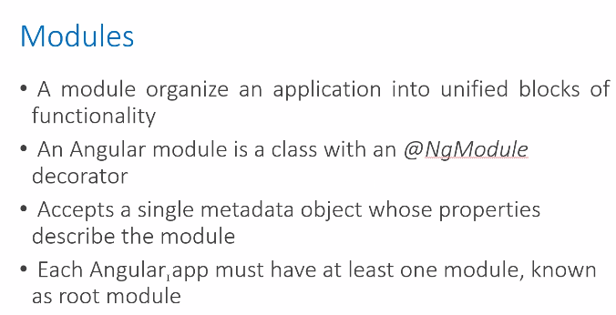

**JAVASCRIPT MODULES:**

**In writing big javascript project we instead of writing whole code in single file we use multiple files,and make them as Global scopic .to make it available for all other files. but problem with this approach is that all are public and available in all other files which may result in naming conflicts of variables and function names if they are same.’**

**🡪what way system.js helpful in writing efficient javascript?**

**System.js will help by splitting them into Modules and loads them into our html file which ever module is needed and this helps in two ways.**

**1.it Provides Encapsulation by Only exposing given pieces that want to access as public and hiding Component’s Implementation Details .We do that with “EXPORT’” Statement and “IMPORT “ Statements.System,js analyzes our Code and Looks for import and export statements and only when the code is executed does the Loading of files is done into html file**

Module-1 module-2 index.html

🡪.in our index file we load system.js and configuration for system.js.the configuration tells

1.systemsjs where to look to find files that are imported using a **MAP** for .example: /app/folder

2. Tells systemjs where is **starting point** for the application in the **packages file.from that point system.js Knows which files has to be loaded when they are needed for**

**example main.js** 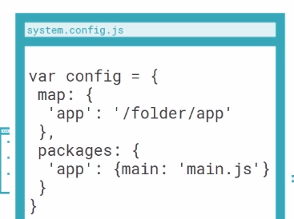

startingpoint here

**Components in detail Revisited:**

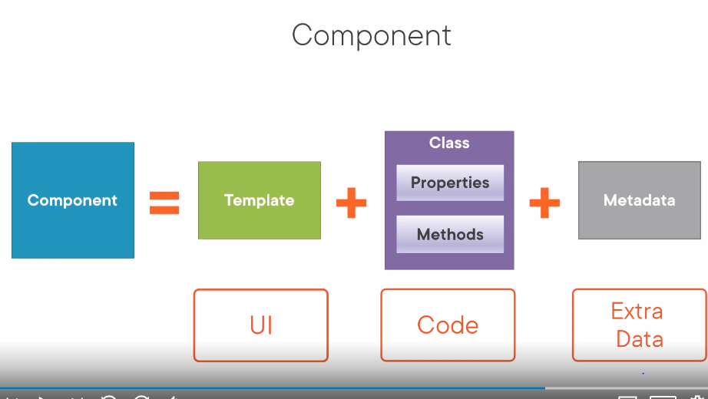

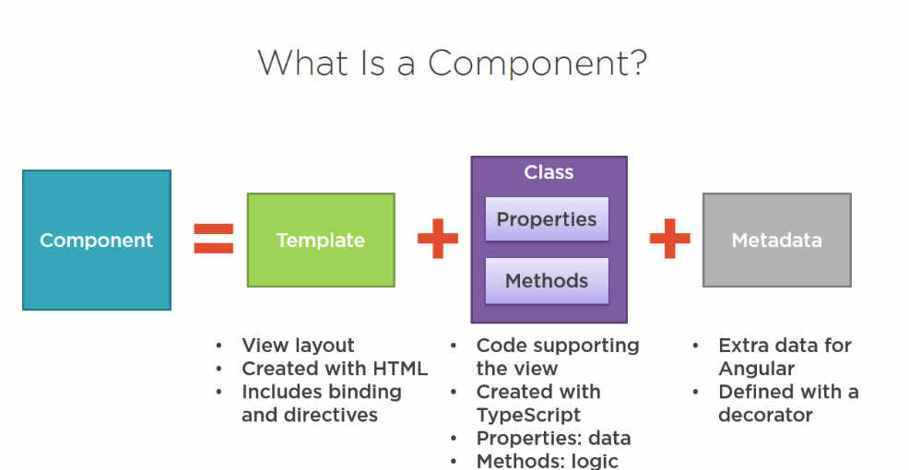

**Component includes one Template**

**1.Template:it is Created with Html. We use angular Bindings and Directives in view**

**2.Class:Code is Associated with A view with Class supporting view and class is created in TypeScript.class contains properties for data elements available for view.forexample:if we want to display title we define a property in class for title.it contains Methods Contains the Logic needed for the view.forexample if we want to show or hide the image we will write a logic in methods in class.Class Name is should be suffixed with Component like appComponent**

**3.Metadata:Metadata defines the Class as Angualr Component Medata is defined with A DECORATOR “@”**Decorators are proposed for a future version of javaScript, but the Angular team really wanted to use them, and they have been included in TypeScript.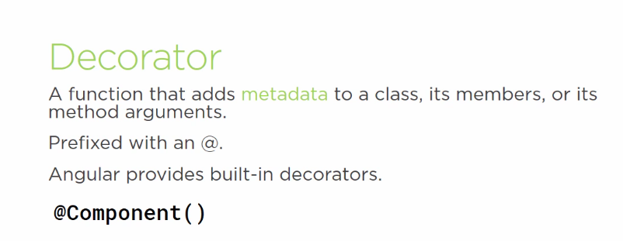

**Lets Examin a COMPONENT IN TYPESCRIPT.** @Component decorator will receive two parameters,

(1)the AppComponent class, and

(2)the configuration object that has the

selector and template properties.

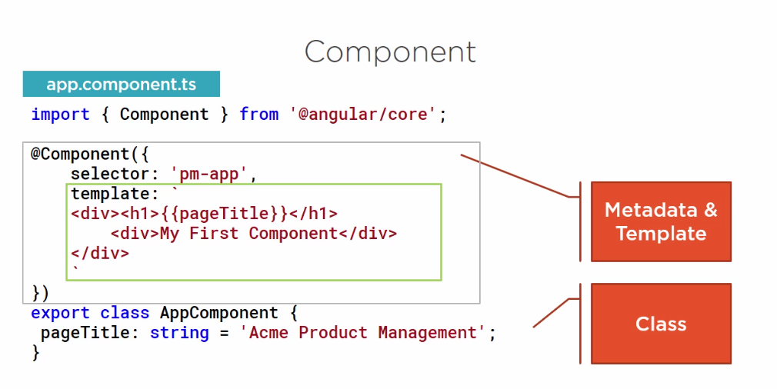

DECORATOR

**Will Explore Now each part of Component in depth :**

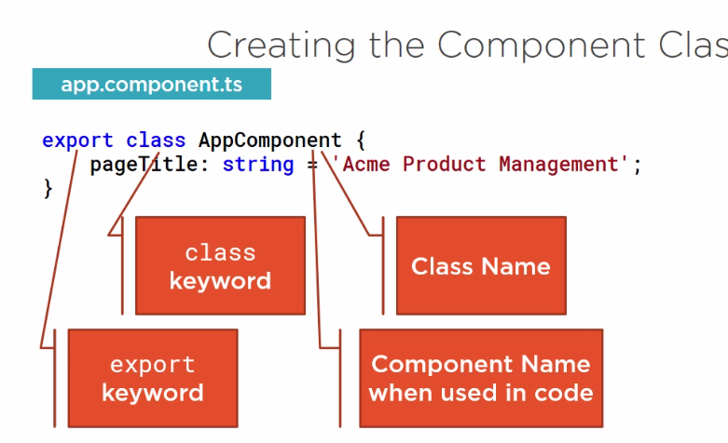

**Class is created with class keyword and name is named with feature name suffixed with Component. Root Component By Convention named as appcomponent.this class name is referenced in other components in the application.since this exports something it is called a ES6MODULE and will be loaded by Module Loader.no need to write a script Tag.**

**Syntax:Property Name:DataType=’value’ or DefaulValue**

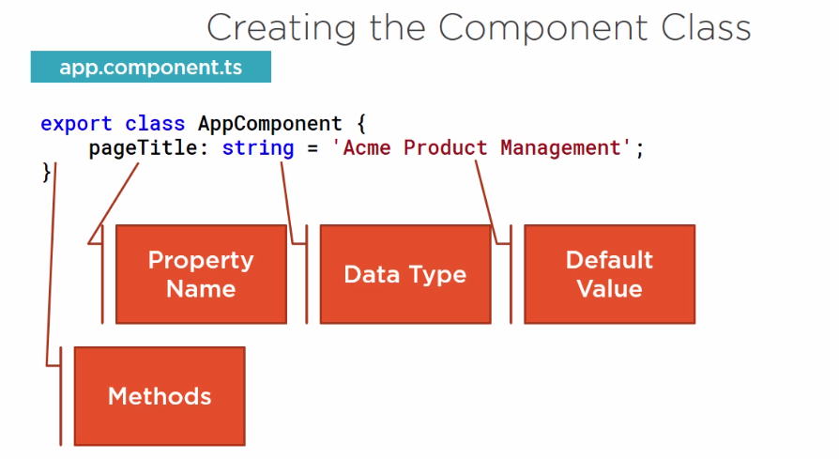

**1.Property name should be in camelcase name starting with lowercase. Methods are defined after all the properties defined. Method names are often verbs that define the actions performed by methods. Next we will see metadata**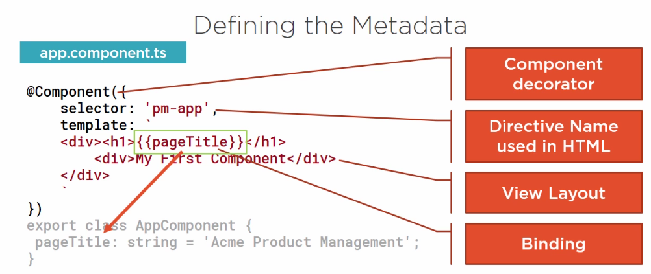

**A class becomes a Component when it is given Metadata.** Component decorator allows you to mark a class as an [Angular](https://angular.io/docs/ts/latest/api/core/index/Component-decorator.html) component and provide additional metadata that determines how the component should be processed, instantiated and used at runtime.

We define component’s metadata with angular component function in typescript we attach that function to class as a Decrorator.we can decorator above class always

**🡪Decorator is a function that’s why it has parenthesis ()**

**🡪We pass an object as parameter to the Component function hat’s why we use { } curly braces. The object we pass in has many properties like “selector” and “template”.**

**🡪if we plan to refer the component in any html we use SELECTOR.the selector defines component’s directive name directive a directive is a custom html tag. Whenever html is used angular renders the component’s template.**

**🡪the double curly braces indicate data binding we bind H1 value to Pagetitle.proeperty of the class so when the HTML is Rendered h1 element renders the ACME PRODUCT Mangement.**

**IMPORT:it is part of es6 and implemented in TypeScript.we tell module loader to import any library or package .it’s like using in c# and import in java**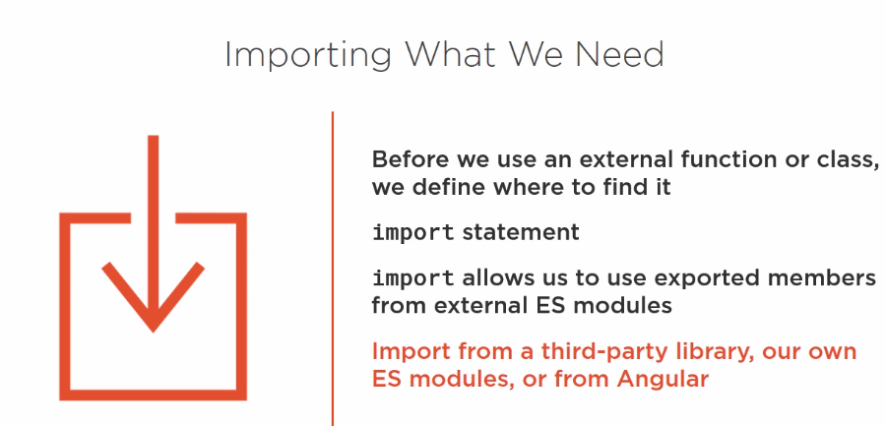

**In our component code we use the Component function to define our class as component.**

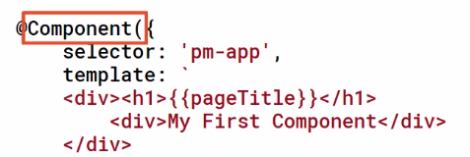

**We We can import from angular because angular is modular.it is a collection of Library of Modules**

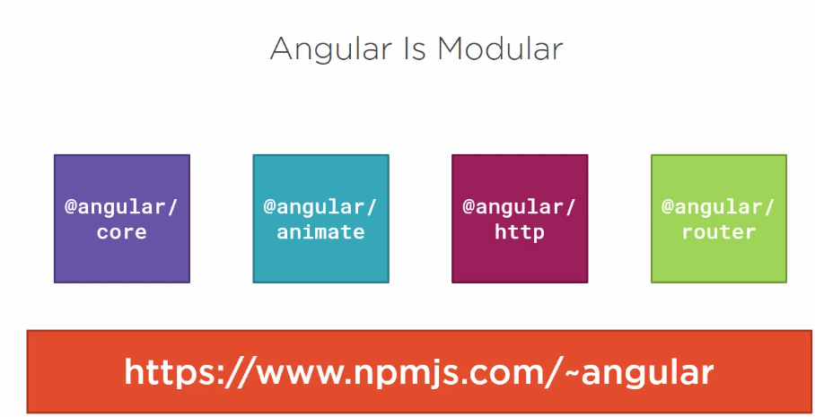

**We need to tell to angular where to find this function so use import**

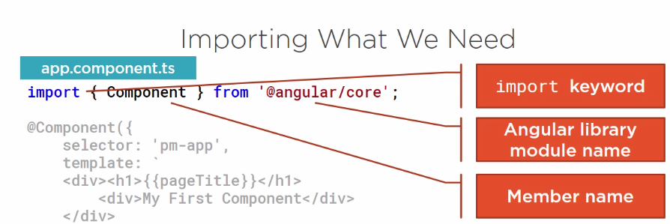

**What If we want multiple components from angular ?we write in curly brace separated by commas**

# Chapter-2 :Data Binding in Angular

## ****Data Binding in Angular Application****

**Data binding** is one of the most important features provided by **Angular Framework** which allows communicating between the **component** and its **view**. So, at the end of this article, you will understand the following pointers in detail.

1. **Why do we need Data Binding?**
2. **What is Data Binding in Angular?**
3. **Types of Data Binding**

##### **Why do we need Data Binding?**

Whenever you want to develop any data-driven web application, then as a developer you need to keep the focus on two important things i.e

. Data and the UI (User Interface) and it is more important for you to find an efficient way to bind them (Data and UI) together. Again, the data can arrive in several chunks and you need to update the user interface with the latest or updated data.

Now a day most of the front-end development uses JavaScript frameworks like Angular which does a lot of work for us. These Frameworks takes the responsibility of synchronizing the data and the user interface. The angular framework provides one concept called Data Binding which is used for synchronizing the data and the user interface (called a view).

##### **What is Data Binding in Angular Application?**

In Angular, Data Binding means to bind the data (Component’s filed) with the View (HTML Content). That is whenever you want to display dynamic data on a view (HTML) from the component then you need to use the concept Data binding.

**Data Binding is a process that creates a connection to** communicate and synchronize between the user interface and the data. In order words, we can say that Data Binding means to interact with the data and view. So, the interaction between the templates (View) and the business logic is called data binding.

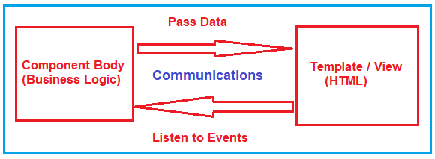

##### **Types of Data Binding in Angular:**

There are two types of Data binding available. They are as follows

1. **One-way Data Binding-** where a change in the state affects the view (i.e. From Component to View Template) or change in the view affects the state (From View Template to Component).
2. **Two-way Data Binding-** where a change from the view can also change the model and similarly change in the model can also change in the view (From Component to View Template and also From View template to Component).

In order to understand this better and remember, please have a look at the following image which describes the classification of Data Binding.

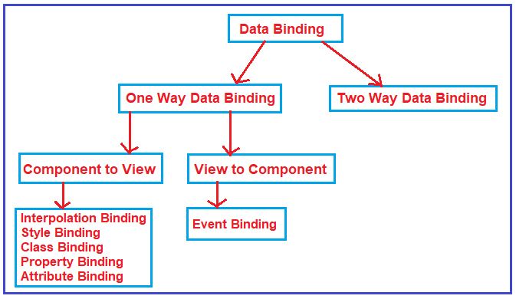

##### **Examples of Angular Data Bindings:**

1. [**Interpolation**](https://dotnettutorials.net/lesson/angular-interpolation/)
2. [**Property Binding**](https://dotnettutorials.net/lesson/angular-property-binding/)
3. [**Attribute Binding**](https://dotnettutorials.net/lesson/angular-attribute-binding/)
4. [**Class Binding**](https://dotnettutorials.net/lesson/angular-class-binding/)
5. [**Style Binding**](https://dotnettutorials.net/lesson/angular-style-binding/)
6. [**Event Binding**](https://dotnettutorials.net/lesson/angular-event-binding/)
7. [**Two-way binding**](https://dotnettutorials.net/lesson/angular-two-way-data-binding/)

**Chaptee-2**

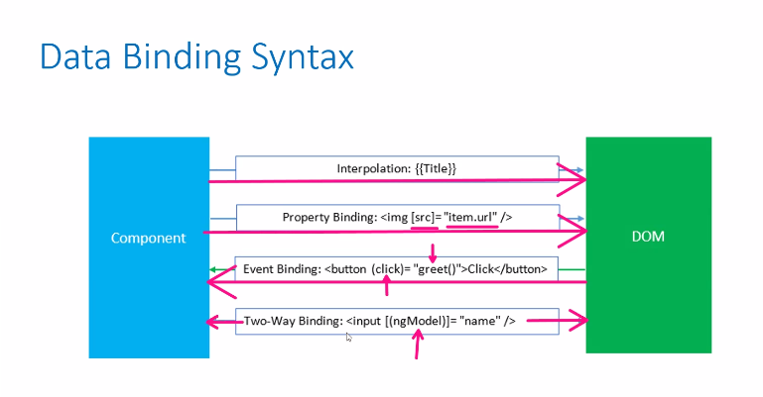

# Angular Interpolation

## ****Angular Interpolation with Examples****

##### **What is Angular Interpolation?**

If you want to display the read-only data on a view template (i.e. From Component to the View Template), then you can use the one-way data binding technique i.e. the Angular interpolation.

The Interpolation in Angular allows you to place the component property name in the view template, enclosed in double curly braces i.e. **{{propertyName}}**.  So, the Angular Interpolation is a technique that allows the user to bind a value to a UI element.

##### **Understanding Interpolation in Angular Application:**

Let us understand how to use the Interpolation with some examples.

###### **Step1: Modify the index.html**

Please modify the index.html file as shown below.

<!doctype html>

**<html** lang="en"**>**

**<head>**

**<meta** charset="utf-8"**>**

**<title>**MyAngularApp**</title>**

**<base** href="/"**>**

**<meta** name="viewport" content="width=device-width, initial-scale=1"**>**

**<link** rel="icon" type="image/x-icon" href="favicon.ico"**>**

**</head>**

**<body>**

**<app-root></app-root>**

**</body>**

**</html>**

##### **Step2: modify app.component.ts file.**

In order to understand Angular Interpolation binding, please have a look at the following image. Here, we have created two string variables (FirstName and LastName) within the component (i.e. AppComponent) and initialize these two variables with some default values. Then please focus on the template property of the @Component decorator. Here, the angular framework gets the value of the FirstName and LastName property from the component (i.e. AppComponent) and then inserts the FirstName and LastName value between the opening and closing <h1> element. Here, we are using double curly braces to place to component properties and this is called Interpolation binding in Angular Application.

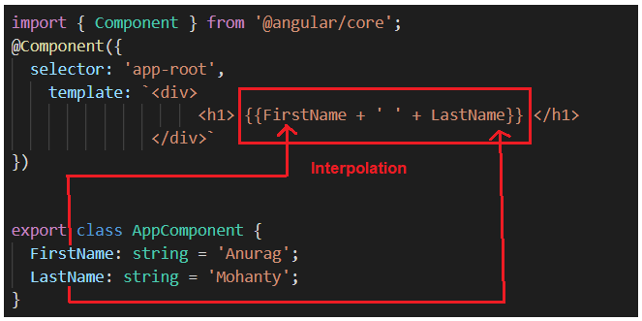

So, open **app.component.ts** file and then copy and paste the following code in it.

**import** **{** Component **}** from '@angular/core';

@Component**({**

selector: 'app-root',

template: `<div>

<h1> {{FirstName + ' ' + LastName}} </h1>

</div>`

**})**

**export** **class** AppComponent **{**

FirstName: **string** = 'Anurag';

LastName: **string** = 'Mohanty';

**}**

And, when you run the application, then it should display the FirstName and LastName in the browser as shown in the below image.

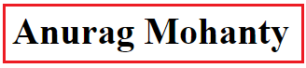

##### **Angular Interpolation with hardcoded string:**

It is also possible in Angular to concatenate some hard-coded string value with the property value. In order to understand this, let us add the hard-coded string First Name before the FirstName Property and Last Name before the LastName property. If this is your requirement then you could do this as shown in the below image.

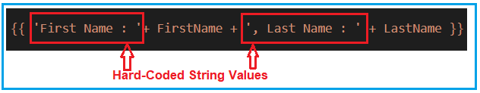

So, please modify the app.component.ts file as shown below.

**import** **{** Component **}** from '@angular/core';

@Component**({**

selector: 'app-root',

template: `<div>

<h1> {{ 'First Name : '+ FirstName + ', Last Name : ' + LastName }} </h1>

</div>`

**})**

**export** **class** AppComponent **{**

FirstName: **string** = 'Anurag';

LastName: **string** = 'Mohanty';

**}**

With the above changes in place, now you should get the FirstName and LastName property values along with the hardcoded string values as shown in the image below.



##### **Angular Interpolation with Expression:**

In Angular using Interpolation (i.e. double curly braces), you can also specify some valid expression. For example, if you want to perform mathematical calculations then you can do such calculations using interpolation as shown in the below image.

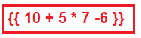

So, modify the **app.component.ts** file as shown below and then see the output in the browser.

**import** **{** Component **}** from '@angular/core';

@Component**({**

selector: 'app-root',

template: `<div>

<h1> 10 + 5 * 7 - 6 = {{ 10 + 5 * 7 -6 }} </h1>

</div>`

**})**

**export** **class** AppComponent **{**

**}**

###### **Output:**

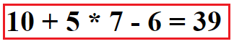



The template expression might be a JavaScript expression, but usually, it is the component’s property.

Template expression can be:

* method calls {{methodCall()}}
* JS expression {{}}
* Math {{2 * 8 / 67}}
* Conditional expression
* String concatenation {{‘string’ + ‘concatenation’}}

It is left for the Angular compiler to detect which one it is in the list above and generate compiled code accordingly.

## ****Angular Property Binding with Examples****

.

1. **What is Angular Property Binding?**
2. **How to use Property Binding in Angular Application?**
3. **Different kinds of examples to understand Property Binding.**
4. **What are the differences between Property Binding and Interpolation?**
5. **Working with non string data.**
6. **Angular Interpolation with Boolean data**
7. **Providing Security to Malicious Content**

##### **What is Angular Property Binding?**

**The Property Binding in Angular Application is used to bind the values of component or model properties to the HTML element.** Depending on the values, it will change the existing behavior of the HTML element. The

syntax to use property is:

**[property] = ‘expression’**

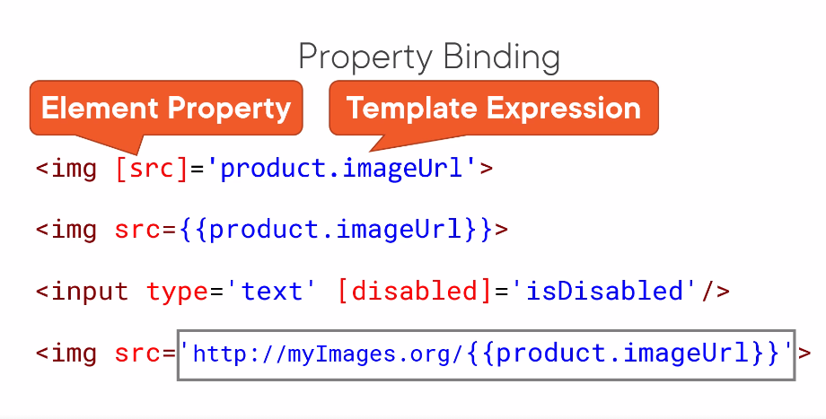

In Property Binding, there is a source and target. For example, consider the below span tag.

**span[innerHTML] = ‘FirstName’.**

Here, innerHTML is the target that is a property of span tag and FirstName is the source that is the component property.

##### **How to use the Property Binding in Angular Application?**

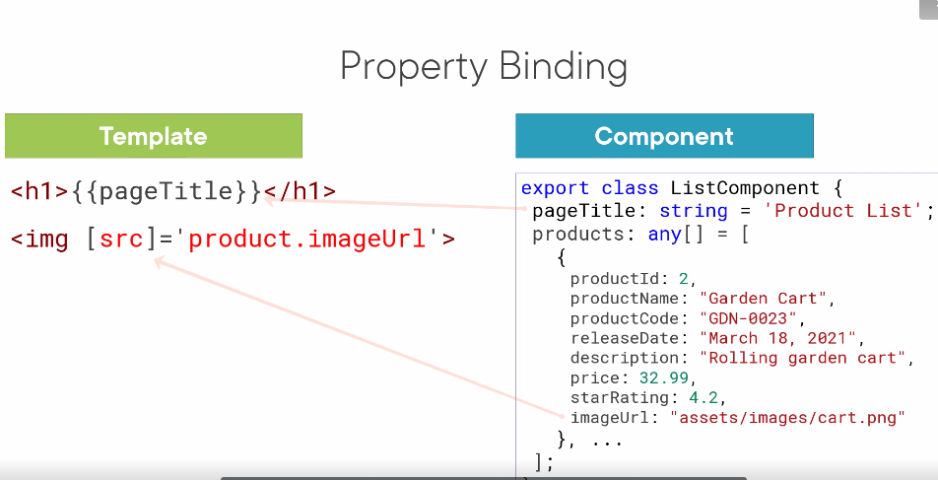

**@Component({  
template: `  
<div>  
<img [src]="imageURL" />  
</div>  
`  
})  
export class AppComponent {  
imageURL = "./images/k.png"  
constructor() {  
setInterval(()=>this.imageURL = './images/p.png', 1000)  
}  
}**

he img element's src property is bound to the imageURL property in the AppComponent class. The src property in the img element is used to set the image that will be displayed on the element.

We can get the HTMLImgElement instance and refer to the src property to set the image on the img element.

const imgElement = document.getElementById('img_1');  
imgElement.src = './images/p.png';  
imgElement.src = './images/k.png';

If the imageURL property changes in the AppComponent class the src property in the img element will be changed. When rendered it will be like this:

<div>  
 <img [src]="imageURL" />  
 </div>|  
v<div>  
 <img src="./images/p.png" />  
 </div>

After the imageURL changes after 1ms interval by setInterval(...) call. This will be rendered.

<div>  
 <img [src]="imageURL" />  
</div>|  
v<div>  
 <img src="./images/k.png" />  
</div>

So when we use [] on element properties we are telling Angular that the property should take the value of the Model's property passed to it.

**Component Binding**

@Component({  
 template: `  
 <child [data]="dataSource"></child>   
 `  
})  
export class Parent {  
 dataSource = 'My Source'  
 constructor() {  
 setInterval(()=> this.dataSource = "My S" + Date.now(),1000)  
 }  
}@Component({  
 selector: 'child',  
 template: `  
 <h2>{{data}}</h2>  
 `  
})  
export class Child {  
 @Input data  
}

The Child component is rendered on the Parent markup. The Parent uses [] to bind data property of Child to its dataSource property. When the dataSource changes the data property in the child is updated to reflect the new changes. In Angular components use the @Input decorator to tell which property is open to the outside world.

So in our case, child appended @Input to data property because it will be bound to by the parent component.

In order to understand how to use property binding in the angular application, please have a look at the following image. As you can see in the below image, you need to specify the HTML element property (in our example, the HTML element is span and the property is innerHTML) in a pair of the square brackets. Then you need to specify the component class property (in our example, the component class is AppComponent and the property is Title) in a pair of single quotes. Then at runtime, this property value will be assigned to the HTML Property.

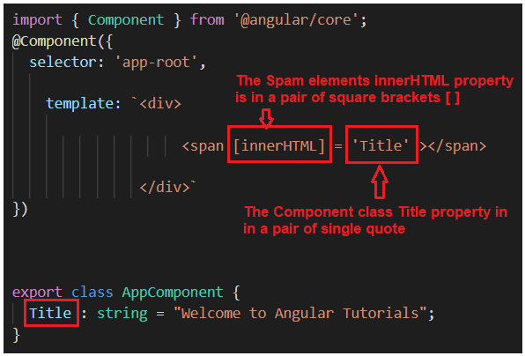

So, please modify the app.component.ts file as shown below to use the property binding to bind the component property values to the HTML elements property.

**import** **{** Component **}** from '@angular/core';

@Component**({**

selector: 'app-root',

template: `<div>

<span [innerHTML] = 'Title' ></span>

</div>`

**})**

**export** **class** AppComponent **{**

Title : **string** = "Welcome to Angular Tutorials";

**}**

Now, save the changes and have a look at the browser and you should get the output as expected as shown in the below image.

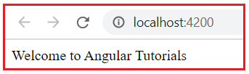

In this way, you can use property binding in angular application.

##### **Achieving the same thing using Angular Interpolation and Property Binding:**

we had made one point that we can achieve the same thing using property binding as we achieve using Angular Interpolation.

, we use the following code to bind component class ImagePath property to the **<img>** element’s **src** property using the interpolation technique.

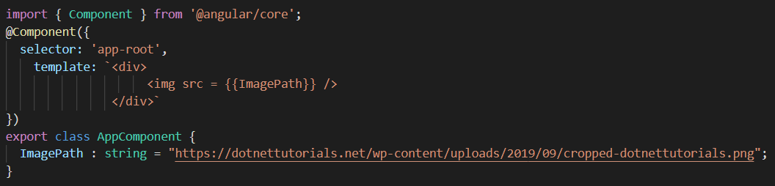

Now, let’s see how we can achieve the same thing using Property Binding. With property binding what you need to do is, you need to specify the src property of the image element in a pair of the square brackets and then you need to specify the ImagePath property of the component class in a pair of the single quotes as shown in the below image.

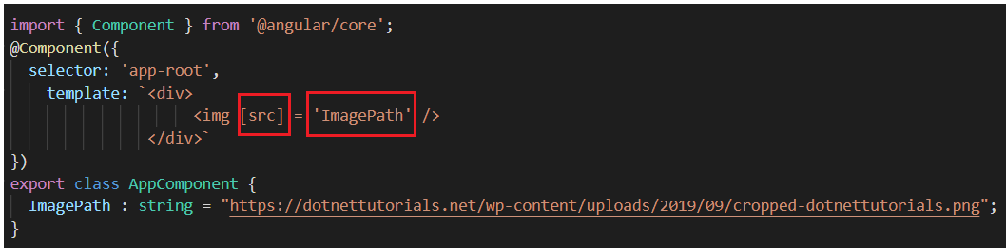

**So, modify the app.component.ts file as shown below and see the output in the browser which should the image as expected.**

**import** **{** Component **}** from '@angular/core';

@Component**({**

selector: 'app-root',

template: `<div>

<img [src] = 'ImagePath' />

</div>`

**})**

**export** **class** AppComponent **{**

ImagePath : **string** = "https://dotnettutorials.net/wp-content/uploads/2019/09/cropped-dotnettutorials.png";

**}**

**Note:** The **Angular Interpolation**and **Property binding**both flows the values from a component to the view template i.e. in one direction.

Now, you may have one question i.e. we can achieve the same thing using both property binding and angular interpolation, then what is the difference between them or when to use one over another.

##### **What is the difference between Property Binding and Angular Interpolation?**

Interpolation in Angular is just an alternative approach for property binding. It is a special type of syntax that converts into a property binding.

But there are some scenarios where we need to use interpolation instead of property binding.

For example, if you want to concatenate strings then you need to use angular interpolation instead of property binding as shown in the below image.

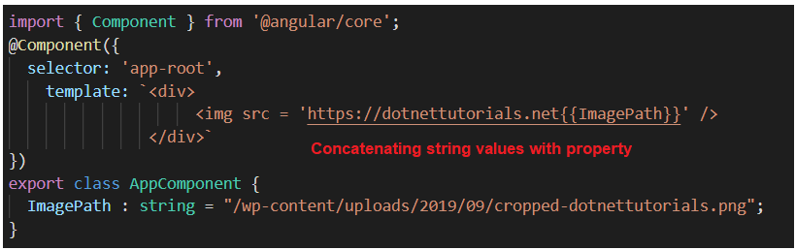

##### **Working with non-string (Boolean) data:**

**When you are working with non-string values like Boolean to set the property value of an HTML element, then you need to use property binding instead of interpolation**

. For example, if you want to disable a button click event, then you need to set the disabled property of the button element using the property binding as shown in the below code.

**import** **{** Component **}** from '@angular/core';

@Component**({**

selector: 'app-root',

template: `<div>

<button [disabled] = 'IsDisabledClick' > Cick Here </button>

</div>`

**})**

**export** **class** AppComponent **{**

IsDisabledClick : **boolean** = **true**;

**}**

With the above changes in place, it will display the button in the browser which is not clickable. Let see what happens if we use angular interpolation.

##### **Angular Interpolation with Boolean data:**

Please modify the app.component.ts file as shown below to use angular interpolation to set the disabled property of the button element. Here, we set the property value to false.

**import** **{** Component **}** from '@angular/core';

@Component**({**

selector: 'app-root',

template: `<div>

<button disabled = {{IsDisabledClick}} > Cick Here </button>

</div>`

**})**

**export** **class** AppComponent **{**

IsDisabledClick : **boolean** = **false**;

**}**

* **With the above changes in place, irrespective of the IsDisabledClick property value of the component class, the button is always disabled.**

Here we set the IsDisabled property value as false but when you run the application, it will not allow the button to be clickable.

##### **Providing Security to Malicious Content:**

From the security point of view, both Angular data binding and Angular Interpolation protect us from malicious HTML content before rendering it on the web browser. Let us understand this with an example. In the following example, we are using angular interpolation to bind the malicious <script> tag.

**import** **{** Component **}** from '@angular/core';

@Component**({**

selector: 'app-root',

template: `<div>

{{MaliciousData}}

</div>`

**})**

**export** **class** AppComponent **{**

MaliciousData : **string** = "Hello <script>alert('your application is hacked')</script>";

**}**

Now, when we run the application, the Angular interpolation sanitizes the malicious content and displays the following in the browser.

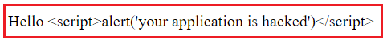

###### **In the below example we are using property binding.**

**import** **{** Component **}** from '@angular/core';

@Component**({**

selector: 'app-root',

template: `<div [innerHTML] = 'MaliciousData'>

</div>`

**})**

**export** **class** AppComponent **{**

MaliciousData : **string** = "Hello <script>alert('your application is hacked')</script>";

**}**

The Property Binding handles the malicious HTML content in a slightly different manner and when you run the application, you will get the following output in the browser. But the most important point that you need to keep in mind is, both property binding and interpolation protect us from malicious HTML content.

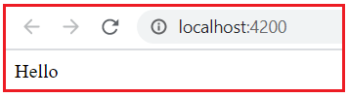

# HTML Attribute VS DOM Property

## ****HTML Attribute VS DOM Property with Example****

##### **What is DOM?**

The DOM stands for Document Object Model. When a browser loads a web page, then the browser creates the Document Object Model (DOM) for that page. For example, let say we have a page with the following HTML.

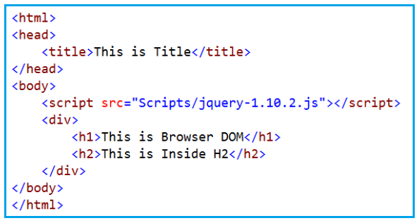

When the above HTML is loaded by the browser, then it creates the Document Object Model (DOM) as shown in the below image.

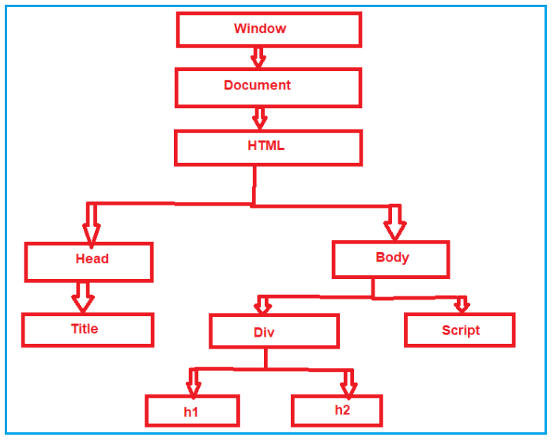

So in simple words, we can say that the DOM is an application programming interface (API) for the HTML, and we can use the programming languages like JavaScript or JavaScript frameworks like Angular to access and manipulate the HTML using their corresponding DOM objects.

**In other words, we can say that the DOM contains the HTML elements as objects**, their properties, methods, and events and it is a standard for accessing, modifying, adding or deleting HTML elements. In our last two articles,

**Interpolation example: <button disabled='{{IsDisabled}}’>Click**

**Me</button>**

**Property binding example: <button [disabled]=’IsDisabled’>Click Me</button>**

If you look at the above two examples, you may feel that you are binding to the Button’s disabled attribute, but that is not true.

**You are actually binding to the disabled property of the button object. So, the Angular data-binding is all about binding to the DOM object properties and not the HTML element attributes.**

##### **What is the difference between the HTML element attribute and DOM property?**

1. The Attributes are defined by HTML Elements whereas the properties are defined by the DOM.
2. The attribute’s main role is to initializes the DOM properties. So, once the DOM initialization complete, the attributes job is done.
3. Property values can change, whereas the attribute values can never be changed.

**Let’s prove this –** The Property values can change, whereas the attribute values can never be changed with an example.

In the below example, we have set the value attribute of the input HTML element to Anurag.

**import** **{** Component **}** from '@angular/core';

@Component**({**

selector: 'app-root',

template: `<div>

<input id='inputId' type='text' value='Anurag'>

</div>`

**})**

**export** **class** AppComponent **{**

**}**

At this point, run the application and you will see the value Anurag in the textbox as expected as shown in the below image.

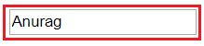

##### **Getting the Attribute and Property Value**

Now, launch the browser developer tools by pressing the F12 key and then click on the Console Tab. On the ‘**Console**‘ tab, use the **getAttribute()** method and the **value** property of the input element to get the attribute and property values. Notice at the moment both have the value Anurag. The **GetAttribute()** Method provides you with the attribute value of the HTML Element.

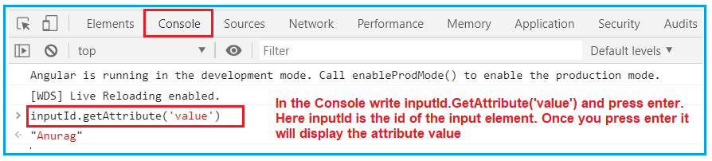

**The Value Property of the DOM** object provides you the property value as shown in the below image.

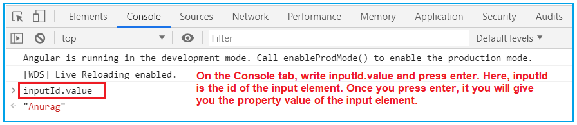

Now, change the value in the textbox to Mohanty on the webpage. And do the same thing once more as shown below.

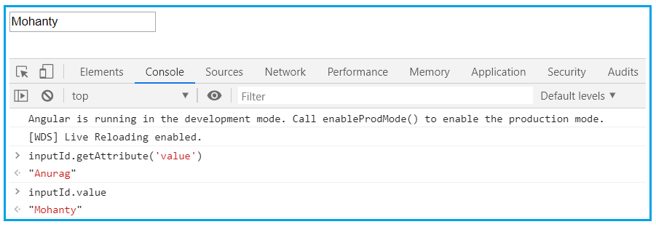

* **Now, when we query for the attribute and property values,**
* **the attribute value is still Anurag but the property value is changed to Mohanty.**
* **So this proves that the Property values changes whereas the attribute values never changed.**

##### **So, the points to remember is that,**

1. The HTML attributes and DOM properties are two different things.
2. Angular binding works with the properties and events, and not with the attributes.
3. The job of attributes is to initialize the DOM object properties.

# Angular Attribute Binding

## ****Angular Attribute Binding with Examples****

**Angular Attribute Binding** with examples. Please read our previous article where we discussed [**HTML Attribute vs DOM Property**](https://dotnettutorials.net/lesson/html-attribute-vs-dom-property/) in Detail. At the end of this article, you will understand the following pointers in detail.

1. **What is Attribute Binding in Angular?**
2. **Why we need Attribute Binding in Angular Application?**
3. **Understanding Angular Attribute Binding with an Example**
4. **Using Angular Interpolation**
5. **Using Property Binding and Attribute Binding in Angular**

##### **Why we need Attribute Binding in Angular Application?**

In our [**Angular Interpolation**](https://dotnettutorials.net/lesson/angular-interpolation/)and [**Property Binding**](https://dotnettutorials.net/lesson/angular-property-binding/) we discussed that they both (Interpolation and Property Binding) are dealing with the DOM Properties but not with the HTML attributes

**. But there are some HTML elements (such as colspan, area, etc) that do not have the DOM Properties**.

* ***The property binding binds to the*properties*of DOM elements, components, and directives and not to HTML attributes. The angular has a special syntax for attribute binding.***

**The Answer is Angular Attribute Binding.**

With Attribute Binding in Angular, you can set the value of an HTML Element Attribute directly. So, the Attribute Binding is used to bind the attribute of an element with the properties of a component dynamically.

##### **Understanding Angular Attribute Binding with an Example:**

**Let us understand the need and use of Angular Attribute Binding with an example. We want to do here is, we want to show the Details of a Student on a webpage as shown in the below image.**

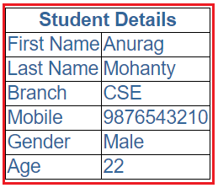

Let us see how to achieve this step by step.

##### **Step1: Modify the app.component.css file**

First, open app.component.css file which you can find inside the app folder and then copy and paste the following styles into it. These are the styles that we want to apply to the table.

table **{**

color: *#369*;

font-family: Arial, Helvetica, sans-serif;

font-size:large;

border-collapse: collapse;

**}**

td **{**

border: 1px solid black;

**}**

thead**{**

border: 1px solid black;

**}**

##### **Step2: Modify the app.component.html file**

Open **app.component.html** file and then copy and paste the following code in it. You can also find this file inside the app folder. Here, we have created one table to display the student details. Again here we are using angular interpolation i.e. double curly braces to bind the student data.

**<table>**

**<thead>**

**<tr>**

**<th** colspan="2"**>**

{{pageHeader}}

**</th>**

**</tr>**

**</thead>**

**<tbody>**

**<tr>**

**<td>**First Name**</td>**

**<td>**{{FirstName}}**</td>**

**</tr>**

**<tr>**

**<td>**Last Name**</td>**

**<td>**{{LastName}}**</td>**

**</tr>**

**<tr>**

**<td>**Branch**</td>**

**<td>**{{Branch}}**</td>**

**</tr>**

**<tr>**

**<td>**Mobile**</td>**

**<td>**{{Mobile}}**</td>**

**</tr>**

**<tr>**

**<td>**Gender**</td>**

**<td>**{{Gender}}**</td>**

**</tr>**

**<tr>**

**<td>**Age**</td>**

**<td>**{{Age}}**</td>**

**</tr>**

**</tbody>**

**</table>**

##### **Step3: Modify the app.component.ts file**

Modify the **app.component.ts** file as shown below. Here within the component decorator, we are providing the stylesUrl and templateUrl values to the external files that we just modified in our previous two steps. Then as part of the Component class, we are creating the required student properties with some value as well as the header value.

**import** **{** Component **}** from '@angular/core';

@Component**({**

selector: 'app-root',

templateUrl: './app.component.html',

styleUrls: **[**'./app.component.css'**]**

**})**

**export** **class** AppComponent **{**

pageHeader: **string** = 'Student Details';

FirstName: **string** = 'Anurag';

LastName: **string** = 'Mohanty';

Branch: **string** = 'CSE';

Mobile: **number** = 9876543210;

Gender: **string** = 'Male';

Age: **number** = 22;

**}**

Now, with the above changes in place, if you browse the application (**ng serve -o**), you will get the output as expected.

##### **Using Angular Interpolation:**

**If you notice, here we have hardcode the colspan value to 2 in the HTML file i.e. in the app.component.html file.**

***Let us say we also want to bind this (colspan) value from a property of the component class.***

***🡪 To do so, let us add a new property with the name ColumnSpan in the AppComponent (app.component.ts file) class as shown in the below image.***

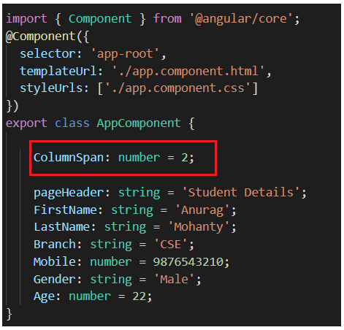

Now, you may be intended to use the ColumnSpan property to set the colspan attribute of the th element using angular interpolation as shown in the below image.

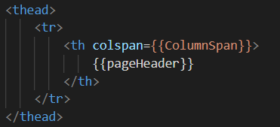

Once you compiled, you will get the following error.

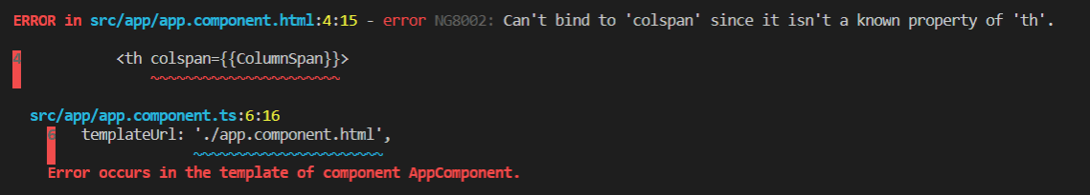

Now, have a look at the browser, and you will not get the output as expected as shown in the below image. The colspan is not working here.

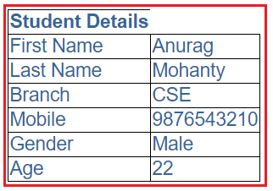

In order to see what went wrong, launch the browser developer tools by pressing the F12 key and open the Console tab as shown in the below image.

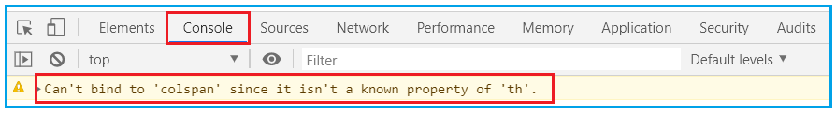

It clearly shows that you “**Can’t bind to ‘colspan’ since it isn’t a known property of ‘th’**”. So, you cannot use angular interpolation to bind the colspan attribute of th element.

##### **Using Property Binding in Angular:**

You will also get the same error if you try to bind the colspan property using the Property Binding Technique. Let us prove this. First, modify the colspan binding in the app.component.html file as shown below.

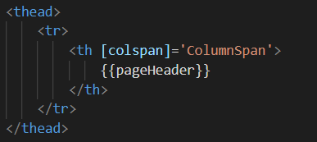

With the above Property Binding in place, now if you compile the project, then you will get the same error as shown in the below image.

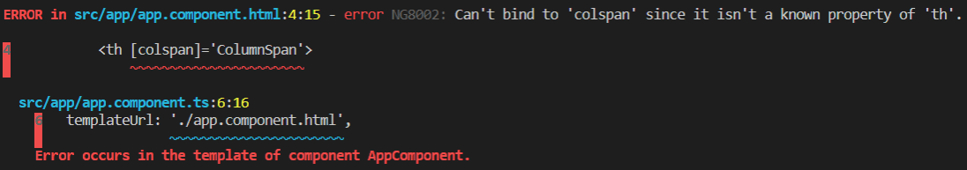

* We get the above error. The reason for this error is, we do not have a corresponding property in the DOM for the colspan attribute.
* In order to solve the above error, what you need to do is you need to use Angular Attribute Binding, which will set the colspan attribute value.

##### **Using Attribute Binding in Angular:**

To tell the angular framework that we are setting an attribute value,

we have to prefix the attribute name with the attr and a DOT as shown below.

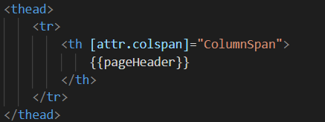

The same is also true when we are using angular interpolation as shown in the below image.

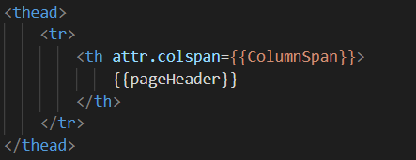

Now run the application and you should get the output as expected.

**Note:** The Angular team recommends using the property binding or Interpolation whenever possible and use the attribute binding only when there is no corresponding element property to bind.

Example

<table>

        <thead>

        <tr>

        <th [attr.colspan]='columnspan'>

          <th attr.colspan={{columnspan}}>

        {{pageHeader}}

        </th>

        </tr>

        </thead>

        <tbody>

        <tr>

        <td>First Name</td>

        <td>{{FirstName}}</td>

        </tr>

        <tr>

        <td>Last Name</td>

        <td>{{LastName}}</td>

        </tr>

        <tr>

        <td>Branch</td>

        <td>{{Branch}}</td>

        </tr>

        <tr>

        <td>Mobile</td>

        <td>{{Mobile}}</td>

        </tr>

        <tr>

        <td>Gender</td>

        <td>{{Gender}}</td>

        </tr>

        <tr>

        <td>Ag <table>

<thead>

<tr>

<th [attr.colspan]='columnspan'>

<th attr.colspan={{columnspan}}>

{{pageHeader}}

</th>

</tr>

</thead>

<tbody>

<tr>

<td>First Name</td>

<td>{{FirstName}}</td>

</tr>

<tr>

<td>Last Name</td>

<td>{{LastName}}</td>

</tr>

<tr>

<td>Branch</td>

<td>{{Branch}}</td>

</tr>

<tr>

<td>Mobile</td>

<td>{{Mobile}}</td>

</tr>

<tr>

<td>Gender</td>

<td>{{Gender}}</td>

</tr>

<tr>

<td>Age</td>

<td>{{Age}}</td>

</tr>

</tbody>

</table>

</body>

</html>e</td>

        <td>{{Age}}</td>

        </tr>

        </tbody>

        </table>

</body>

</html>

App.component,ts

export class AppComponent {

 viewpageHeader: string = 'Cutomer Details';

FirstName: string = 'Anurag';

LastName: string = 'Mohanty';

Branch: string = 'CSE';

Mobile: number = 9876543210;

Gender: string = 'Male';

Age: number = 22;

columnspan:number=2;

}

# Example-2

|  |
| --- |
| **//Template**    **//Setting aria label**  **<button [attr.aria-label]="closeLabel" (onclick)="closeMe()">X</button>**    **//Table colspan**  **<table border="1">**  **<tr>**  **<td>Col 1</td>**  **<td>Col 2</td>**  **<td>Col 3</td>**  **</tr>**  **<tr>**  **<td [attr.colspan]="2">Col 1 & 2</td>**  **<td>Col 3</td>**  **</tr>**  **<tr>**  **<td>Col 1</td>**  **<td bind-attr.colspan = "getColspan()">Col 2 & 3 </td>**  **</tr>**  **<tr>**  **<td>Col 1</td>**  **<td>Col 2</td>**  **<td>Col 3</td>**  **</tr>**    **</table>** |

|  |  |
| --- | --- |
| **1**  **2**  **3**  **4**  **5**  **6**  **7**  **8** | **//Component**    **closeLabel="close";**  **getColspan() {**  **return "2"**  **}** |

# Angular Class Binding

## ****Angular Class****

##### **What is Angular CSS Class Binding?**

The Angular Class Binding is basically used to add or remove CSS classes to and from the HTML elements.

It is also possible in Angular to add CSS Classes **conditionally to an element,** which will create the dynamically styled elements and this is possible because of Angular Class Binding.

### Class binding

* You can set the class in the following ways
* [ClassName Property binding](https://www.tektutorialshub.com/angular/class-binding-in-angular/#class-binding-with-classname):
* [Set the Class attribute with class binding](https://www.tektutorialshub.com/angular/class-binding-in-angular/)
* [ngClass directive](https://www.tektutorialshub.com/angular/angular-ngclass-directive/)

## Class binding with ClassName

The ClassName is the property name of HTML Element. Hence we can make use of Property binding to assign the class name to any HTML element.

The following example assigns CSS Class red to the div element.

<div [className]="'red'">Test</div>

|  |  |
| --- | --- |
|  |  |

You can also add more than one class by separating them using the

* **<div [className]="'red size20'">Test</div>**

##### **Understanding Class Binding in Angular Application:**

Let us understand Angular Class Binding with an example. First, open the **styles.css** file and then copy and paste the following code in it. You can find styles.css file within the src folder of your project.

**.boldClass{**

font-weight:bold;

**}**

**.italicClass{**

font-style:italic;

**}**

**.colorClass{**

color:red;

**}**

**Note:** Please make sure to have a reference to this **styles.css** file in the **index.html** file which is your host page as shown in the below image.

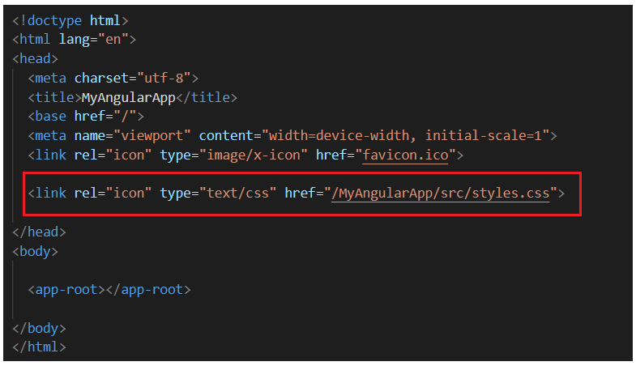

##### **Modifying app.component.ts file:**

Modify the app.component.ts file as shown below. Here we are just adding a button element as well as we also set the class attribute of the button element to ‘**colorClass**‘. If you remember this **colorClass** class is defined in the styles.css file.

**import** **{** Component **}** from '@angular/core';

@Component**({**

selector: 'app-root',

template: `<div>

<button class='colorClass'>Click Me</button>

</div>`

**})**

**export** **class** AppComponent **{**

**}**

Now run the application and you should see the **‘colorClass’** is applied to the button element as expected as shown in the below image.

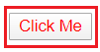

##### **Using Class Binding in Angular:**

Let us see how to use class binding in angular. To do so, first, modify the **app.component.ts file** as shown below. Here, as you can see, we have created a property called **ClassesToApply** in the **AppComponent** class. We have also specified the class binding for the button element. The word ‘**class**‘ is in a pair of square brackets and it is bound to the property ‘**ClassesToApply**‘.

**import** **{** Component **}** from '@angular/core';

@Component**({**

selector: 'app-root',

template: `<div>

<button [class] = 'ClassesToApply' >Click Me</button>

</div>`

**})**

**export** **class** AppComponent **{**

ClassesToApply : **string** = 'italicClass boldClass';

**}**

Once you save changes, then you will get the following output. Here you can see the button is italic as well as bold.

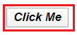

If you want then you can also combine both class binding with the normal class as shown in the below example.

**import** **{** Component **}** from '@angular/core';

@Component**({**

selector: 'app-root',

template: `<div>

<button class='colorClass' [class] = 'ClassesToApply' >Click Me</button>

</div>`

**})**

**export** **class** AppComponent **{**

ClassesToApply : **string** = 'italicClass boldClass';

**}**

Now you should get the button with all the three CSS classes like the color red, bold and italic as shown in the below image.

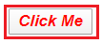

##### **Adding or removing a single class:**

Suppose you want to add or remove a single class, then you need to include use the prefix ‘class’ within a pair of square brackets and followed by a DOT (.) and the name of the class that you want to add or remove.

The following example adds the boldClass to the button element. Notice it does not remove the existing colorClass which is added using the class attribute.

**import** **{** Component **}** from '@angular/core';

@Component**({**

selector: 'app-root',

template: `<div>

<button class='colorClass' [class.boldClass]='ApplyBoldClass'>Click Me</button>

</div>`

**})**

**export** **class** AppComponent **{**

ApplyBoldClass: **boolean** = **true**;

**}**

Now, if run the application, then you should see the button with red color and bold. If you set the ApplyBoldClass property value to false or remove the property altogether from the AppComponent class, then the CSS class i.e. boldClass will not be added to the button element. In the following example, we have set the ApplyBoldClass property value to false and when you browse the application, you will see the button without bold.

**import** **{** Component **}** from '@angular/core';

@Component**({**

selector: 'app-root',

template: `<div>

<button class='colorClass' [class.boldClass]='ApplyBoldClass'>Click Me</button>

</div>`

**})**

**export** **class** AppComponent **{**

ApplyBoldClass: **boolean** = **false**;

**}**

##### **Angular Class Binding using “!” symbol:**

In Angular Class Binding, it is also possible to use the “!” symbol. Notice in the following example, we have set ApplyBoldClass property value to false. As we use the “!” symbol in the class binding, the class is going to be added to the button element.

**import** **{** Component **}** from '@angular/core';

@Component**({**

selector: 'app-root',

template: `<div>

**<button class='colorClass' [class.boldClass]='!ApplyBoldClass'>Click Me</button>**

</div>`

**})**

**export** **class** AppComponent **{**

ApplyBoldClass: **boolean** = **false**;

**}**

Now, if you run the application, then you should the bold class is applied to the button element as expected.

##### **How to remove an existing class using Class Binding in Angular?**

Let us understand this with an example i.e. how to remove an existing class that is already applied by using Angular Class Binding. Consider the below example. Here we have 3 classes (colorClass, boldClass, and italicsClass) added to the button element using the class attribute. Then the class binding removes the boldClass.

**import** **{** Component **}** from '@angular/core';

@Component**({**

selector: 'app-root',

template: `<div>

<button class='colorClass italicClass boldClass' [class.boldClass]='ApplyBoldClass'>Click Me</button>

</div>`

**})**

**export** **class** AppComponent **{**

ApplyBoldClass: **boolean** = **false**;

**}**

That’s fine. But if we want to add or remove multiple classes then how we can do this?

##### **Add or Remove multiple classes in Angular:**

In order to add or remove multiple style classes in angular**, the angular framework provides one directive called ngClass directive** which you can use to remove or add multiple classes as shown in the below example.

What is a directive and what are the different types of directives that we will discuss in detail in our upcoming articles. For now, let us see how to use the ngClass directive to add or remove multiple classes.

import { Component } from '@angular/core';

@Component({

selector: 'app-root',

template: `**<div>**

**<button** class='colorClass' [ngClass]='AddCSSClasses()'**>**Click Me**</button>**

**</div>**`

})

export class AppComponent {

ApplyBoldClass: boolean = true;

ApplyItalicsClass: boolean = true;

AddCSSClasses() {

let Cssclasses = {

boldClass: this.ApplyBoldClass,

italicsClass: this.ApplyItalicsClass

};

return Cssclasses;

}

}

##### **What we are doing here?**

1. Here the colorClass is added using the class attribute
2. The ngClass directive is bind to the **AddCSSClasses()** method of the AppComponent class
3. Here, **AddCSSClasses() is method that returns an object with 2 key/value pairs.** The key is the CSS class name and the value can be true or false
4. . If the value is true then it will add the class and when the value is False then it will remove the class.
5. Since both the keys (boldClass & italicsClass) are set to true, both classes will be added to the button element
6. The **let**is a new type of variable declaration in JavaScript. **let**is similar to var in some respects. In our upcoming article, we will discuss let and var in detail as well as discuss the differences between them. For this example, you can also use var and it should work.

# Event Binding in Angular

# Event Binding in Angular

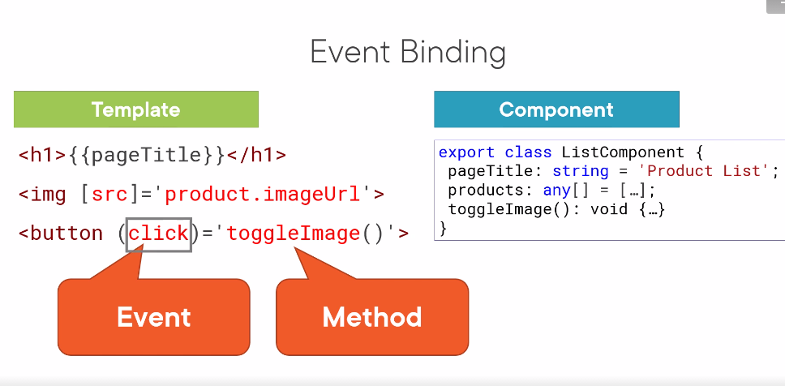

A component listens for user actions using event binding. Event binding allows us to connect an event to a method in the component. Here is an HTML button element. We bind the button's click event to the toggleImage method in our component. When the user clicks the button, the binding executes the code in the toggleImage method. With event binding, the event name is enclosed in parentheses. The method name is followed by open and closing parentheses and is enclosed in quotes. Wondering where to find a list of valid HTML element events? Check out this link. The Mozilla Developer Network provides a thorough list of standard events, along with some documentation.

## Event Binding Example

Create a new angular application

|  |  |
| --- | --- |
|  | ng new event |

Copy the following code to app.component.html

***app.component.html***

|  |
| --- |
| <h1 [innerText]="title"></h1><h2>Example 1</h2>  <button (click)="clickMe()">Click Me</button>  >You have clicked {{clickCount}}</p |

Add the following code to the app.component.ts

***app.component.ts***

|  |
| --- |
| clickCount=0    clickMe() {      this.clickCount++;    } |

|  |  |  |
| --- | --- | --- |
| Event Name | How to Call | Description |
| Click | **(click)=”clickFunction()”** | When we need to do some action on element click on that time bind these event on that element. |
| Double Click | **(dblclick)=”dbclickFunction()”** | When we need to do some action on double click on element at that time bind these event. |
| Blur | **(blur)=”blurFunction()”** | The blur event fires when an element has lost focus. Mainly used in Form elements. |
| Focus | **(focus)=”focusFunction()”** | The focus event fires when an element has received focus.Mainly used in Form elements. |
| Submit | **(submit)=”submitFunction()”** | When we want to submit form we trigger “submit” event. |
| Scroll | **(scroll)=”scrollFunction()”** | When we Scroll the page it fires these event. |
| Event Name | How to Call | Description |
| Keyup | **(keyup)=”keyupFunction()”** | The keyup event is fired when a key is released from the keyboard. |
| Keypress | **(keypress)=”keypressFunction()”** | The keypress event is fired when a key that produces a character value is pressed down. |
| Keydown | **(keydown)=”keydownFunction()”** | The keydown event is fired when a key is pressed. |
| Mouse Up | **(mouseup)=”mouseupFunction()”** | The mouseup event is fired at an Element when a button on a pointing device (such as a mouse) is released while the pointer is located inside it. |
| Mouse Down | **(mousedown)=”mousedownFunction()”** | The mousedown event is fired at an Element when a pointing device button is pressed while the pointer is inside the element. |
| Mouse Enter | **(mouseenter)=”mouseenterFunction()”** | The mouseenter event is fired at an Element when a pointing device (usually a mouse) is initially moved so that its hotspot is within the element at which the event was fired. |

|  |  |  |
| --- | --- | --- |
| Event Name | How to Call | Description |
| Cut | **(cut)=”cutFunction()”** | The cut event is fired when the user has initiated a “cut” action through the browser’s user interface. |
| copy | **(copy)=”copyFunction()”** | The copy event fires when the user initiates a copy action through the browser’s user interface. |
| Paste | **(paste)=”pasteFunction()”** | The paste event is fired when the user has initiated a “paste” action through the browser’s user interface. |
| Drag | **(drag)=”dragFunction()”** | The DragEvent interface is a DOM event that represents a drag and drop interaction. The user initiates a drag by placing a pointer device. |
| Drop | **(drop)=”dropFunction()”** | Drop event fire when we leave the pointing device. |
| Dragover | **(dragover)=”dragoverFunction()”** | The dragover event is fired when an element or text selection is being dragged over a valid drop target. |

Let’s create a demo for event binding. let’s add below code in the “app.component.html” & “app.component.ts”.

* [**app.component.ts**](https://www.eduforbetterment.com/lists-of-useful-events-types-for-event-binding-in-angular/)
* [**app.component.html**](https://www.eduforbetterment.com/lists-of-useful-events-types-for-event-binding-in-angular/)

import { Component, VERSION } from '@angular/core';

@Component({

selector: 'my-app',

templateUrl: './app.component.html',

styleUrls: [ './app.component.css' ]

})

export class AppComponent {

name = 'Angular ' + VERSION.major;

clickEvent(){

alert('Simple click event fired');

}

dblclickEvent(){

alert('Double click event fired');

}

blurEvent(){

console.log('Blur event fired');

// alert('Blur event fired');

}

focusEvent(){

console.log('Focus event fired');

//alert('Focus event fired');

}

copyEvent(){

alert('Copy event fired');

}

cutEvent(){

alert('Cut event fired');

}

pasteEvent(){

alert('Paste event fired');

}

}

Events are handled in Angular using the following special syntax.

(target event name) = "template statement"

Bind the target event name within parentheses on the left of an equal sign, and event handler method or statement on the right.

Example: Binding Button Click Event

 Copy

<button (click)="onShow()">Show</button>

Above, (click) binds the button click event and onShow() statement calls the onShow() method of a component.

Example: Handle Button Click Event in Component

@Component({

selector: 'event-demo,

template: '<button (click)="onShow()" >Show</button>'

})

export class EventBindingDemoComponent implements OnInit {

constructor() { }

ngOnInit(): void {

}

onShow() {

alert('Show button clicked!');

}

}

Alternatively, use the on- prefix, known as the canonical form:

Example: on-event

**<button on-click="onShow()" >Show</button>**

By default, an event propagates up to the parent container event. In the following example, click event propagates to click of div and will call both the onShow() and onDivClick() methods.

Example: Event Bubbling

<div (click)="onDivClick()">

<button (click)="onShow()" >Show</button>

</div>

## $event

Mostly, when an event is raised, you may need to pass some value to the event handler function. This value can be number, string, or an object that contains information about an event.

You can pass the number or string value to the event handler function, as shown below.

Example: Passing Event Data

<button (click)="onShow(20)">Show</button>

Angular includes $event that contains the information about an event. The type of $event depends on the target event, e.g., if the target event is a native DOM element event, then it is an object.

Example: $event

<button (click)="onShow($event)">Show</button>

A component should define the onShow(event) method where the type of the parameter can be KeyboardEvent, MouseEvent, etc. If you don't know the exact event type, they use “any” type, as shown below.

Example: event Parameter

onShow(event:any) {

console.log(event);

}

If event is a native DOM element event then $event.target get DOM element reference using which you can access element's property e.g. $event.target.innerHTML returns the value of innerHTML property of a DOM element.

Example: Event Handling

<button (click)="onShow($event)">Show</button>

//component method

onShow(event:any) {

alert(event.target.innerHTML); // returns Show

}

You can use $event.target in the template statement. The following example binds a component property to $event.target.value of the input box on the input event without using ngModel.

Example: Bind Event without ngModel

<input type="text" (input)="userName=$event.target.value"><br/>

{{userName}}

**Approach:**

* Define a function in the app.component.ts file which will do the given task.
* In the app.component.html file, bind the function to the given event on the HTML element

**Example 2:**Using keyup event on the input element.

**app.component.html**

|  |
| --- |
| **HTML**  **<!-- event is passed to function -->**  **<input (keyup)="onKeyUp($event)">**  **<p>{{text}}</p>** |

**app.component.ts**

|  |
| --- |
| **import { Component } from '@angular/core';**  **@Component({**  **selector: 'app-root',**  **templateUrl: './app.component.html',**  **styleUrls: ['./app.component.css']**  **})**  **export class AppComponent {**  **text = '';**  **onKeyUp(x) {**    **// Appending the updated value**  **// to the variable**  **this.text += x.target.value + ' | ';**  **}**  **}** |

Output

## Multiple event handlers

You can also bind an unlimited number of event handlers on the same event by separating them with a semicolon :

Add a new component property

Add a new component property

clickCount1=0;

<h2>Example 2</h2>

<button (click)="clickMe() ; clickCount1=clickCount">Click Me</button>

<p>You have clicked {{clickCount}}</p>

<p>You have clicked {{clickCount1}}</p>

## Template reference variable

We can also make use of the template reference variable to pass the value instead of $event.

In the template

In the template

|  |  |
| --- | --- |
|  | <h2>Template Reference Variable</h2>  <input #el (input)="handleInput1(el)">  <p>You have entered {{val}}</p>  ngular components can create and emit custom events.  <child (deposit)="depositMoulah()"></child>  The element child is an Angular component not an HTML element. We attached an event to it using the () and passed deposit to it. deposit is no in any way an HTML event. This is a custom event created by Angular.  Angular uses the concept of EventEmitter to create and emit events. The binding component declares an event variable with the Output decorator and sets it equal to a new EventEmitter. This instance of EventEmitter is used to emit events.  The parent component creates a function to receive the message and set it equal to the child property.  @Component({  template: `  <child (deposit)="depositMoulah"></child>   ` }) export class Parent {  depositMoulah() {  // ...  } }@Component({  selector: 'child',  template: `  <h2>Child Component</h2>  ` }) export class Child {  @Output deposit = new EventEmitter()  constructor() {  setInterval(()=>this.deposit.emit(),1000)  } }  When the Child component, calls the .emit() method in the EventEmitter class, the deposutMoulah method in the Parent component is called. The Output decorator tells Angular that the property name is to be used to call the binding event on the Child when the component emits an event from the Parent component.  We can pass data from the Child component to the Parent using this () concept.  @Component({  template: `  Data recieved: {{data}}  <child (deposit)="depositMoulah"></child>   ` }) export class Parent {  data = null;  depositMoulah($event) {  this.data = $event.value  // ...  } }@Component({  selector: 'child',  template: `  <h2>Child Component</h2>  ` }) export class Child {  @Output deposit = new EventEmitter()  constructor() {  setInterval(()=>this.deposit.emit('data from Child' + Date.now()),1000)  }  }  With the .emit() method in the EventEmitter we can pass in the data/message we want to comm to the parent. Then the parent will get the message in the $event object. |

## ****Angular Directives Overview****

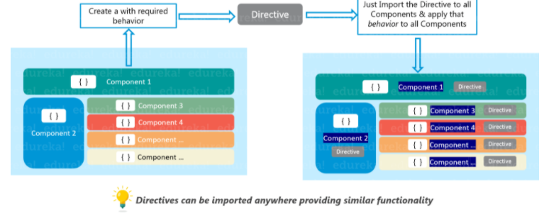

we discussed [**Different Types of Bindings in Angular Application**](https://dotnettutorials.net/lesson/data-binding-in-angular/) with Examples. At the end of this article, you will understand the following important pointers which are commonly asked in angular interviews.

1. **What are Directives?**
2. **Why we need Directives in Angular Application?**
3. **What are the different types of directives available in the Angular Framework?**

**Why Directives Required?**

1. **Reusability** — In an Angular application, the directive is a self-sufficient part of the UI. As a developer, we can reuse the directive across the different parts of the application. This is very much useful in any large-scale applications where multiple systems need the same functional elements like search box, date control, etc.
2. **Readability** — Directive provides much more readability for the developers to understand the production functionality and data flow.
3. **Maintainability** — One of the main use of directive in any application is the maintainability. We can easily decouple the directive from the application and replace the old one with a new one directives.

##### **What are Angular Directives?**

**The Angular Directives are the elements which are basically used to change the behavior or appearance or layout of the DOM (Document Object Model) element.**

In other words, we can say that the directives are basically used to extend the power of HTML attributes and to change the appearance or behavior of a DOM element.

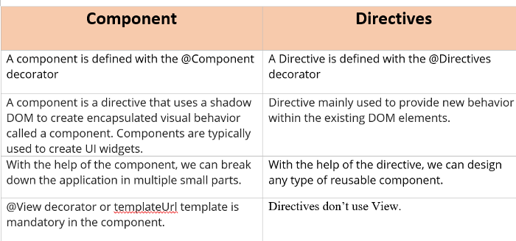

**@Directive Metadata**

1. **selector** — The selector property is used to identify the directive within the HTML template. Also, with the help of this property, we can initialize the directive from the DOM elements
2. **inputs** — It is used to provide the set of data-bound input properties of the directives.
3. **outputs** — It is used to enumerates any event properties from the directives.
4. **providers** — It is used to inject any provider type like service or components within the directives.
5. **exportAs** — It is used to define the name of the directives which can be used to assign a directive

##### **Types of Directives in Angular:**

The Directives are classified into three types based on their behavior. Please have a look at the following image for a better understanding of the directives classification.

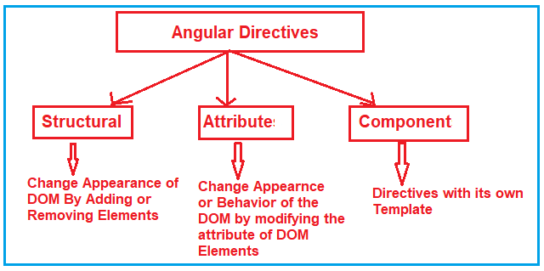

As you can see in the above image, the directives in angular are classified into three types. They are as follows:

1. **Structural Directive**
2. **Attribute Directive**
3. **Component Directives**

Let us discuss each of these directives in detail.

* **\*ngIf Directive:** The ngIf allows us to Add/Remove DOM Element.
* **\*ngSwitch Directive:** The *ngSwitch allows us to Add/Remove DOM Element. It is similar to switch statement of C#.
* **\*ngFor Directive:** The *ngFor directive is used to repeat a portion of HTML template once per each item from an iterable list (Collection).

**Attribute Directives:** Attribute directives are used to change the look and behavior of the DOM elements. For example: ngClass directive, and ngStyle directive etc.

* **ngClass Directive:** The ngClass directive is used to add or remove CSS classes to an HTML element.
* **ngStyle Directive:** The ngStyle directive facilitates you to modify the style of an HTML element using the expression. You can also use ngStyle directive to dynamically change the style of your HTML element.

### Difference between Structural Directive and Attribute Directive

|  |  |
| --- | --- |
| **Structural Directive** | **Attribute Directive** |
| **Structural directives are applied to <template> elements and used to add or remove content (stamp and template).** | **The component has their view (HTML and styles) because of that, there can be one component on a host element, but multiple directives.** |

##### **Structural Directives:**

They are named structural directives because they change the structure of the DOM. For Example ( *ngIf,*ngFor,*ngSwitch).  
  
All structural directives are prefix with *  
All structural directives are prefix with *

The Structural Directives are responsible for the HTML layout. That means, they will shape or reshape the HTML view by simply adding or removing the elements from the DOM. These directives are basically used to handle how the component or the element should render in a template.

In Angular, there are three structural directives are available. They are as follows:

1. **NgFor (*ngFor)**
2. **NgIf (*ngIf)**
3. **NgSwitch (*ngSwitch)**

We will discuss each of each type in detail from our next article.

##### **Attribute Directives:**

Attribute Directives are basically used to modify the behavior or appearance of the DOM element or the Component. In Angular, there are two in-built attribute directives available. They are as follows:

1. **NgStyle**: This NgStyle Attribute Directive is basically used to modify the element appearance or behavior.
2. **NgClass**: This NgClass Attribute Directive is basically used to change the class attribute of the element in the DOM or in the Component to which it has been attached.

We will discuss these two built-in attributes in detail in our

##### **Component Directives:**

We have already discussed Component in our previous articles. The Component is also a type of directive in angular with its own template, styles, and logic needed for the view. The Component Directive is the most widely used directive in the angular application and you cannot create an angular application without a component.

A component directive requires a view along with its attached behavior and this type of directive adds DOM Elements. The Component Directive is a class with **@Component** decorator function

**(1)nigIF directive**

**Syntax:<p *ngIf="condition">**

**Condition is true and ngIf is true.**

**</p>**

**<p *ngIf="!condition">**

**Condition is false and ngIf is false.**

**</p>**

**(2)The *ngIf directive form with an “else” block**

**<div *ngIf="condition; else elseblock">**

**Example-1**

**@Component({**

**selector: ‘ng-if-simple’,**

**template:**

**<button (click)=”show =!show”>{{show ? ‘hide’: ‘show’}}</button>**

**show= {[show}}**

**<br>**

**<div *ngIf=”show”>Text to show</div>**

**`**

**})**

**export class NgIfSimple {**

**show: boolean =true;**

**}**

**Example-2 if and else**

**@Component({**

**selector :’ng-if-else’;**

**template:**

**<button (click) =”show = !show”>{{show ? ‘hide’ : ’show’}}</button>**

**show={{show}}**

**<br>**

**<div *ngIf=”show; else elseBlock’>Text to show</div>**

**<ng-template #elseBlock>Alternate text while primary**

**text is hidden </ng-template>**

**`**

**}]**

**export class NgIfElse{**

**show: boolean = true;**

**}**

import { Component } from '@angular/core';

@Component({

selector: 'Satya-App',

template: `<div style='color:blue' *ngIf="true">You can See Satyaprakash....</div>`

})

export class AppComponent {

1. @Component({
2. selector: 'Satya-App',
3. templateUrl: './app.component.html',
4. })
5. **export** **class** AppComponent {
6. employees: any[] = [
7. {
8. code: '1001', name: 'Satya', gender: 'Male',
9. annualSalary: 5500, dateOfBirth: '25/6/1988'
10. },
11. {
12. code: '1002', name: 'Mohit', gender: 'Male',
13. annualSalary: 5700.95, dateOfBirth: '9/6/1982'
14. },
15. {
16. code: '1003', name: 'Rohit', gender: 'Male',
17. annualSalary: 5900, dateOfBirth: '12/8/1979'
18. },
19. {
20. code: '1004', name: 'Satyaprakash Samantaray', gender: 'Female',
21. annualSalary: 6500.826, dateOfBirth: '14/10/1980'
22. },
23. ];
24. }

}

## ****Angular ngFor Directive****

In this article, I am going to discuss the **Angular ngFor Directive** with an example. Please read our previous article where we discussed the basics of [**Angular Directives**](https://dotnettutorials.net/lesson/angular-directives/). The Angular Directives are one of the most important features of Angular applications. They are used to extend the power of HTML attributes. At the end of this article, you will understand what exactly angular ngFor directive is and when and how to use this directive in Angular Application.

##### **What is Angular ngFor Directive?**

The built-in ngFor directive belongs to the Structural directive category. As it belongs to the structural directive category, it is used to change the structure of the DOM.

The ngFor directive is very much similar to the “for loop” used in most of the programming languages. So, the NgFor directive is used to iterate over a collection of data. The syntax to use ngFor directive is: **\*ngFor=”let <value> of <collection>”**

Here, <value> is a variable name and collection is a property on your component which a collection of data. Usually an array but it can be anything that can be iterated over in a for loop. 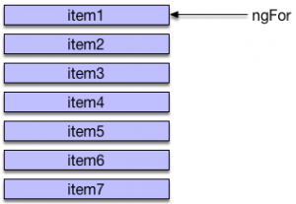

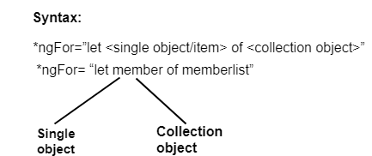

##### **Understanding Angular ngFor Directive:**

Let us understand the ngFor structural directive in angular application with an example. We are going to use the following array of Student objects in this demo.

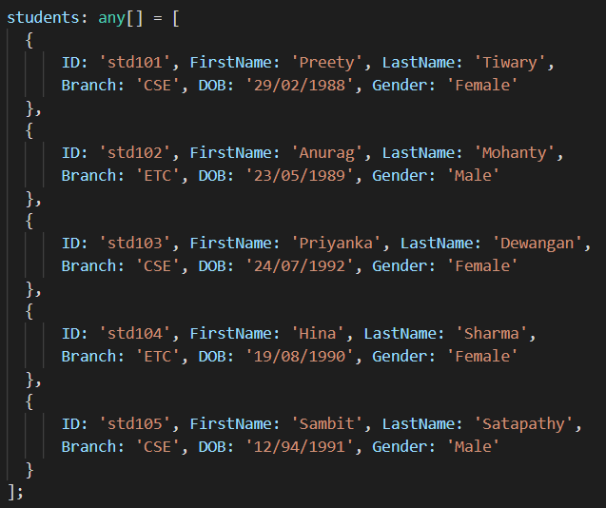

Then we want to display the above students in a table on a web page as shown below.

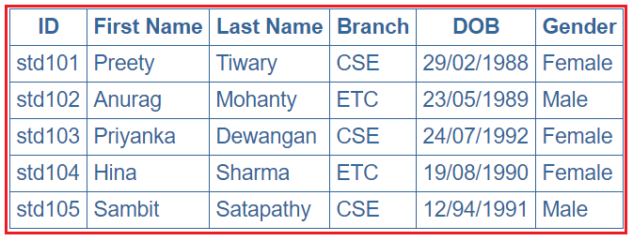

Let’s discuss the Step By Step Procedure to achieve the above output using Angular ngFor Directive:

##### **Step1: Modify the app.component.ts file**

Open **app.component.ts** file and then copy and paste the following code in it. You can find this file within the app folder of your angular project.

**import** **{** Component **}** from '@angular/core';

@Component**({**

selector: 'app-root',

templateUrl: './app.component.html',

styleUrls: **[**'./app.component.css'**]**

**})**

**export** **class** AppComponent **{**

students: **any[]** = **[**

**{**

ID: 'std101', FirstName: 'Preety', LastName: 'Tiwary',

Branch: 'CSE', DOB: '29/02/1988', Gender: 'Female'

**}**,

**{**

ID: 'std102', FirstName: 'Anurag', LastName: 'Mohanty',

Branch: 'ETC', DOB: '23/05/1989', Gender: 'Male'

**}**,

**{**

ID: 'std103', FirstName: 'Priyanka', LastName: 'Dewangan',

Branch: 'CSE', DOB: '24/07/1992', Gender: 'Female'

**}**,

**{**

ID: 'std104', FirstName: 'Hina', LastName: 'Sharma',

Branch: 'ETC', DOB: '19/08/1990', Gender: 'Female'

**}**,

**{**

ID: 'std105', FirstName: 'Sambit', LastName: 'Satapathy',

Branch: 'CSE', DOB: '12/94/1991', Gender: 'Male'

**}**

**]**;

**}**

As you can see in the above code, we have created one array (i.e. students) which a collection of student data. Again we have specified the templateUrl and StyleUrls, so, let proceed and modifies these two files.

##### **Step2: Modify app.component.css file**

Open **app.component.css** file and then copy and paste the following code in it. You can find this file within your app folder. The following styles are going to be used in our HTML page to style table data.

table **{**

color: *#369*;

font-family: Arial, Helvetica, sans-serif;

font-size: large;

border-collapse: collapse;

**}**

td **{**

border: 1px solid *#369*;

padding:5px;

**}**

th**{**

border: 1px solid *#369*;

padding:5px;

**}**

##### **Step3: Modify app.component.html file**

Open **app.component.html** file and then copy and paste the following code in it. You can also find this file within your app folder.

**<table>**

**<thead>**

**<tr>**

**<th>**ID**</th>**

**<th>**First Name**</th>**

**<th>**Last Name**</th>**

**<th>**Branch**</th>**

**<th>**DOB**</th>**

**<th>**Gender**</th>**

**</tr>**

**</thead>**

**<tbody>**

**<tr** *ngFor='let student of students'**>**

**<td>**{{student.ID}}**</td>**

**<td>**{{student.FirstName}}**</td>**

**<td>**{{student.LastName}}**</td>**

**<td>**{{student.Branch}}**</td>**

**<td>**{{student.DOB}}**</td>**

**<td>**{{student.Gender}}**</td>**

**</tr>**

**<tr** *ngIf="!students || students.length==0"**>**

**<td** colspan="7"**>**

No Students to display

**</td>**

**</tr>**

**</tbody>**

**</table>**

##### **Understand the above Code:**

1. Here, the **ngFor**directive is used to iterate over a collection. In this example, the collection is an array of students.
2. As the **ngFor**directive is a structural directive, so it is prefixed with **\* (star)**. So, the point that you need to remember is, all the structural directive are prefixed with a *.
3. **\*ngFor=’let student of students’** – In this statement, the ‘**student**‘ is called template input variable, which can be accessed by the <tr> element and any of its child elements.
4. The **ngIf**structural directive displays the row “**No Students to display**” when the student’s property does not exist or when there are no students in the array. We will discuss this directive in detail in our upcoming articles.

##### **Step4: Modify app.module.ts file**

Open **app.module.ts** file which is present inside the app folder and then copy and paste the following code.

**import** **{** BrowserModule **}** from '@angular/platform-browser';

**import** **{** NgModule **}** from '@angular/core';

**import** **{** AppRoutingModule **}** from './app-routing.module';

**import** **{** AppComponent **}** from './app.component';

**import** **{** FormsModule **}** from '@angular/forms';

@NgModule**({**

declarations: **[**

AppComponent

**]**,

imports: **[**

BrowserModule,

AppRoutingModule,

FormsModule

**]**,

providers: **[]**,

bootstrap: **[**AppComponent**]**

**})**

**export** **class** AppModule **{** **}**

That’s it. We have done with our implementation. Now run the application and you will notice that the students are displayed in the table as expected.

##### **ngFor – Local Variables:**

The ngFor structural directive has the following local variable which you can use to customize the data.

1. **Index**: This variable is used to provide the index position of the current element while iteration.
2. **First**: It returns boolean true if the current element is the first element in the iteration else it will return false.
3. **Last**: It returns boolean true if the current element is the last element in the iteration else it will return false.
4. **Even**: It returns boolean true if the current element is even element based on the index position in the iteration else it will return false.
5. **Odd**: It returns boolean true if the current element is an odd element based on the index position in the iteration else it will return false.

Let us understand the above ngFor local variables one by one with example.

##### **How to get the index of an item in a collection in an angular application?**

We can get the index of an item in a collection using the index property of the ngFor directive. Let us understand this with an example. What we want to do here is, along with the student data, we also want to display the index position as shown in the below image.

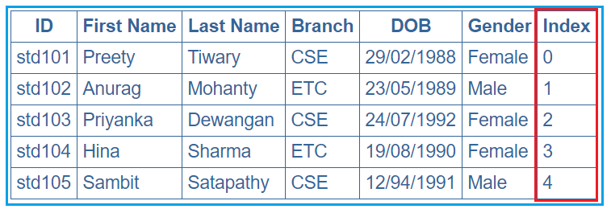

In order to achieve this, we want to use the ngFor local variable index. So, modify the app.component.html as shown below.

**<table>**

**<thead>**

**<tr>**

**<th>**ID**</th>**

**<th>**First Name**</th>**

**<th>**Last Name**</th>**

**<th>**Branch**</th>**

**<th>**DOB**</th>**

**<th>**Gender**</th>**

**<th>**Index**</th>**

**</tr>**

**</thead>**

**<tbody>**

**<tr *ngFor='let student of students; let i=index'>**

**<td>**{{student.ID}}**</td>**

**<td>**{{student.FirstName}}**</td>**

**<td>**{{student.LastName}}**</td>**

**<td>**{{student.Branch}}**</td>**

**<td>**{{student.DOB}}**</td>**

**<td>**{{student.Gender}}**</td>**

**<td>**{{i}}**</td>**

**</tr>**

**</tbody>**

**</table>**

Notice that in the above code, we are using the index property of the Angular ngFor directive to store the index position of an element in a template input variable “i”. The variable “i” is then used in the <td> element where we want to display the index value. We used the let keyword to create the template input variable “i”.  The let keyword in angular is very much similar to the var keyword.

The index of an element is extremely useful when you are creating the HTML elements dynamically. We will discuss creating the HTML elements dynamically in our upcoming articles.

##### **How to identify the first and the last elements in a collection in an angular application?**

To identify the First and Last elements in a collection, you need to use the first and last properties of the ngFor directive respectively. Let us understand this with an example. We want to display the student data along with whether that student is the first or the last student as shown in the below image.

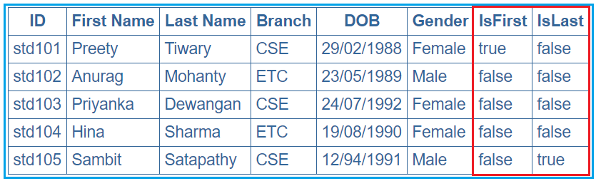

In order to achieve this, modify the **app.component.html** file as shown below.

**<table>**

**<thead>**

**<tr>**

**<th>**ID**</th>**

**<th>**First Name**</th>**

**<th>**Last Name**</th>**

**<th>**Branch**</th>**

**<th>**DOB**</th>**

**<th>**Gender**</th>**

**<th>**IsFirst**</th>**

**<th>**IsLast**</th>**

**</tr>**

**</thead>**

**<tbody>**

**<tr** *ngFor='let student of students; let isFirst = first; let isLast = last'**>**

**<td>**{{student.ID}}**</td>**

**<td>**{{student.FirstName}}**</td>**

**<td>**{{student.LastName}}**</td>**

**<td>**{{student.Branch}}**</td>**

**<td>**{{student.DOB}}**</td>**

**<td>**{{student.Gender}}**</td>**

**<td>**{{isFirst}}**</td>**

**<td>**{{isLast}}**</td>**

**</tr>**

**</tbody>**

**</table>**

##### **How to identify the even and odd elements in a collection in an angular application?**

In order to identify the Event and Odd elements in a collection in angular, you need to use the even and odd local variable of the ngFor directive respectively. Let us understand this with an example. We want to display the student data along with whether that student is odd or even as shown in the below image.

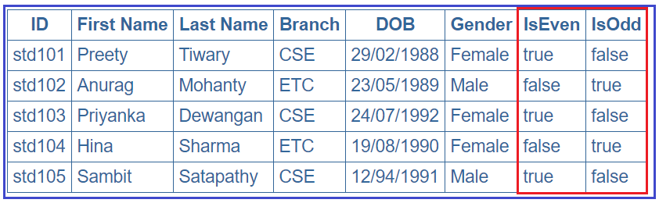

In order to achieve this, modify the **app.component.html** file as shown below.

**<table>**

**<thead>**

**<tr>**

**<th>**ID**</th>**

**<th>**First Name**</th>**

**<th>**Last Name**</th>**

**<th>**Branch**</th>**

**<th>**DOB**</th>**

**<th>**Gender**</th>**

**<th>**IsEven**</th>**

**<th>**IsOdd**</th>**

**</tr>**

**</thead>**

**<tbody>**

**<tr** *ngFor='let student of students; let isEven = even; let isOdd = odd'**>**

**<td>**{{student.ID}}**</td>**

**<td>**{{student.FirstName}}**</td>**

**<td>**{{student.LastName}}**</td>**

**<td>**{{student.Branch}}**</td>**

**<td>**{{student.DOB}}**</td>**

**<td>**{{student.Gender}}**</td>**

**<td>**{{isEven}}**</td>**

**<td>**{{isOdd}}**</td>**

**</tr>**

**</tbody>**

**</table>**

##### **Angular ngIf Directive:**

The ngIf is a structural directive and it is used to add or removes the HTML element and its descendant elements from the DOM layout at runtime conditionally. That means it conditionally shows the inline template.

The ngIf directive works on the basis of a boolean true and false results of a given expression. If the condition is true, the elements will be added into the DOM layout otherwise they simply removed from the DOM layout.

The basic syntax of the ngIf directive is very simple, all we need to do is prefix the directive name with an asterisk (*) as shown below and add it anywhere inside your template. Here if the given “expression” result is false or null, then the elements HTML element and its descendant elements will not be added to the DOM.

**\*ngIf = “expression”**

##### **Example to understand Angular ngIf Directive:**

Please have a look at the following image. As you can, here we have two div Element and we are using the ngIf directive to add or remove the div from the DOM. If the isValid (this is a variable defined in the component class) value is true, then the first div is going to be added into the DOM and if the value is false, then the second div is going to be added into the DOM.

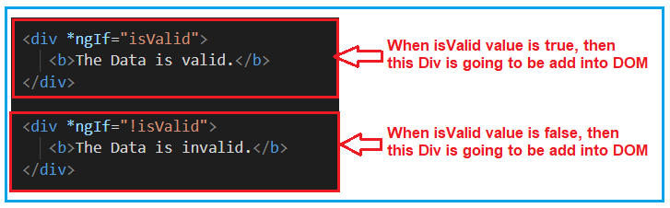

So, first, modify the **app.component.html** file as shown below.

**<div** *ngIf="isValid"**>**

**<b>**The Data is valid.**</b>**

**</div>**

**<div** *ngIf="!isValid"**>**

**<b>**The Data is invalid.**</b>**

**</div>**

Then modify the **app.component.ts** file as shown below.

**import** **{** Component **}** from '@angular/core';

@Component**({**

selector: 'app-root',

templateUrl: './app.component.html',

styleUrls: **[**'./app.component.css'**]**

**})**

**export** **class** AppComponent **{**

isValid: **boolean** = **true**;

**}**

At this moment, change the value of isValid Boolean property (true and false) and check the output in the browser and based on the value, the respective div will be added into the DOM and that you can in the webpage.

##### **Another Example For Better Understanding:**

Let us enhance the same example. Now, instead of hardcoding the isValid Boolean property value, we will set this value from the radio buttons. We will create two radio buttons and based on the selected radio button value we will set the IsValid property value. For better understanding please have a look at the below image.

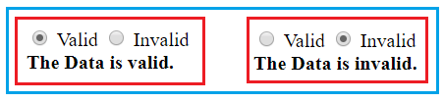

When the Valid radio button is checked, we need to add the first Div to the DOM and when the InValid radio button is checked we need to add the second Div into the DOM. Let’s see how to implement this.

##### **Modify the app.component.ts file:**

Please modify the app.component.ts file as shown below. By default, we set the Boolean isvalid property to true. We have also created one method i.e. ChangeData which accepts a Boolean parameter (in this case valid) and then it set the isValid property value with the incoming parameter value (valid).

**import** **{** Component **}** from '@angular/core';

@Component**({**

selector: 'app-root',

templateUrl: './app.component.html',

styleUrls: **[**'./app.component.css'**]**

**})**

**export** **class** AppComponent **{**

isValid: **boolean** = **true**;

ChangeData**(**valid: **boolean)** **{**

this.isValid = valid;

**}**

**}**

##### **Modify the app.component.html file:**

Please modify the **app.component.html** file as shown below. Here we have created two radio buttons with the name rb. Then we attach our method ChangeData to the click event of the radio button. For the Valid radio button, we are passing true to the ChangeData method and for the Invalid radio button, we are passing false to the ChangeData method.

**<div>**

**<input** type="radio" name="rb" (click)= "ChangeData(true)" checked **>** Valid

**<input** type="radio" name="rb" (click)= "ChangeData(false)"**>** Invalid

**</div>**

**<div** *ngIf="isValid"**>**

**<b>**The Data is valid.**</b>**

**</div>**

**<div** *ngIf="!isValid"**>**

**<b>**The Data is invalid.**</b>**

**</div>**

With the above changes in place, now run the application and you should get the output as expected.

##### **Angular NgIf directive with else block:**

Like other programming languages such as C, Java, and C#, the else is also used when you want to display something for the false condition of NgIf block. The syntax to use the ngIf block with the else block as follows:

**<div *ngIf = “condition; else elseBlock”>…</div>**  
**<ng-template #elseblock>….</ng-tempalte>**

Here, for else block you need to use <ng-template> element. It is referred by a template reference variable. NgIf will use that template reference variable to display the else block when the condition is false.

Let us work with the same example. Please have a look at the following image. In the else block we have created a template variable with the name elseblock (you can give any name as per your choice). So, what will happen here is, it will check the ngIf condition and if the condition is true then it will execute if block. On the other hand, if the condition is false, then it will look for the else block. As we created the else block with the name elseblock, so it searches for ng-template tag followed by template variable name (<ng-template #elseblock>) and add that block to the DOM.

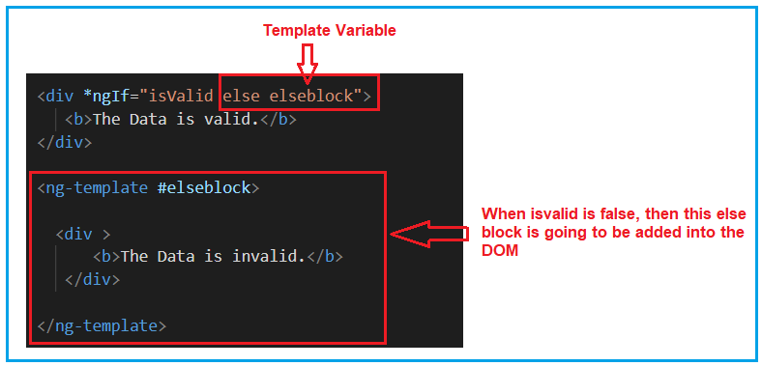

So, modify the **app.component.html** file as shown below and then see the output in the browser.

**<div>**

**<input** type="radio" name="rb" (click)= "ChangeData(true)" checked **>** Valid

**<input** type="radio" name="rb" (click)= "ChangeData(false)"**>** Invalid

**</div>**

**<div** *ngIf="isValid else elseblock"**>**

**<b>**The Data is valid.**</b>**

**</div>**

**<ng-template** #elseblock**>**

**<div** **>**

**<b>**The Data is invalid.**</b>**

**</div>**

**</ng-template>**

##### **NgIf with Then and else:**

The NgIf with then and else is used as follows. When the condition is true then the <ng-template> with the reference variable then block is executed and when the condition is false then the <ng-template> with the reference variable else block is executed. For better understanding please have a look at the following image.

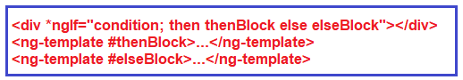

We can have more than one <ng-template> for then and else block and at runtime, we can switch to that ng-template by changing the value of then block and else block. At any given point of time, one ng-template is going to be executed.

So, modify the **app.component.html** file as shown below and then see the output in the browser.

**<div>**

**<input** type="radio" name="rb" (click)= "ChangeData(true)" checked **>** Valid

**<input** type="radio" name="rb" (click)= "ChangeData(false)"**>** Invalid

**</div>**

**<div** *ngIf="isValid then thenblock else elseblock"**>** **</div>**

**<ng-template** #thenblock**>**

**<div>**

**<b>**The is Then Block**</b>**

**</div>**

**</ng-template>**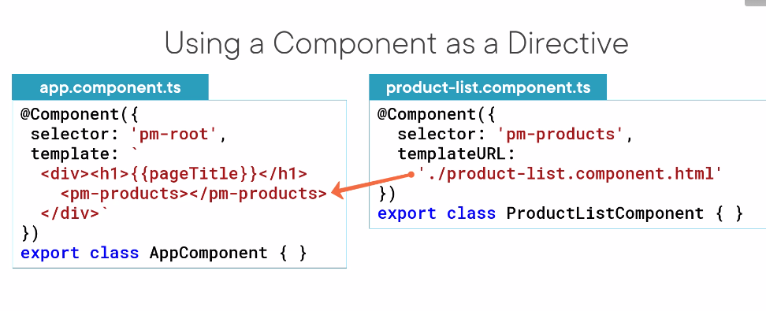

**<ng-template** #elseblock**>**

**<div** **>**

**<b>**The is Else Block**</b>**

**</div>**

**</ng-template>**

##### \**What is the Angular ngSwitch directive?**

The Angular ngSwitch directive is actually a combination of two directives

**i.e. an attribute directive and a structural directive.** It is very similar to the switch statement of other programming languages like Java and C# but within a template.

The ngSwitch directive lets you hide or show the HTML elements based on an expression. Here, you can also define a default section using the ng-switch-default directive to show a section if no other sections get a match. So, while working with ngSwitch directive, you need three things to keep in mind, they are

### Using NgSwitch

NgSwitch is a directive which is bound to an **expression**. NgSwitch is used to display one element tree from a set of many element trees based on some condition. It uses three keywords as follows.  
  
**ngSwitch**: We bind an expression to it that returns the switch value. It uses property binding.  
  
**ngSwitchCase**: Defines the element for matched value. We need to prefix it with asterisk (*).  
  
**ngSwitchDefault**: Defines the default element when there is no match. We need to prefix it with asterisk (*).  
  
Find the code snippet for NgSwitch with bracket **[ ]**.

<ul **[ngSwitch]="person">**

<li *ngSwitchCase="'Mohan'">Hello Mohan</li>

<li *ngSwitchCase="'Sohan'">Hello Sohan</li>

<li *ngSwitchCase="'Vijay'">Hello Vijay</li>

<li *ngSwitchDefault>Bye Bye</li>

</ul>

Here ngSwitch has been assigned with expression person which is a property in component having value "Sohan". So in our switch case the below line of code will run.

<li *ngSwitchCase="'Sohan'">Hello Sohan</li>

If person gives a value which does not match to any of the ngSwitchCase then element with ngSwitchDefault will be execute

##### **Example to understand Angular ngSwitch Directive:**

Let us understand the Angular ngSwitch Directive with an example. What we are going to do is, we will provide a dropdown list to the user to select the country code and based on the selected country code we will provide the full country name. Whenever no country code is selected then it will display you have not selected any country. For example, when you have not selected the country code, then by default the select option is selected from the drop dropdown list and You have not selected any country is displayed as sown in the below image.

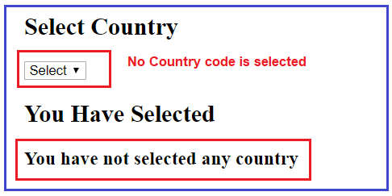

But when selected a particular country code let say IN, then India should display as shown in the below image.

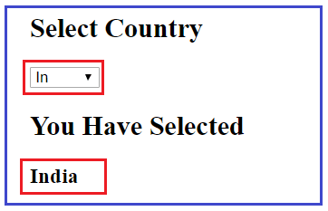

Let us see how to implement the above using Angular ngSwitch directive step by step.

##### **Step1: Modify the app.component.ts file**

First, modify the **app.component.ts** file as shown below. As you can see here, we have created one property i.e. **dropDownValue** and one method i.e. SetDropDownValue. And we are setting the property value using the methods parameter value. This method is going to be called by the dropdown list **change** event.

**import** **{** Component **}** from '@angular/core';

@Component**({**

selector: 'app-root',

templateUrl: './app.component.html',

styleUrls: **[**'./app.component.css'**]**

**})**

**export** **class** AppComponent **{**

**public** dropDownValue = "";

SetDropDownValue**(**drpValue : **any)** **{**

this.dropDownValue = drpValue.target.value;

**}**

**}**

##### **Step2: Modify the app.component.html file**

This is the important part and here you need to understand two things. First, we need to create the drop-down list and then on the change event of the dropdown list, we need to call the **SetDropDownValue** method that we created within our component class. For better understanding please have a look at the following image.

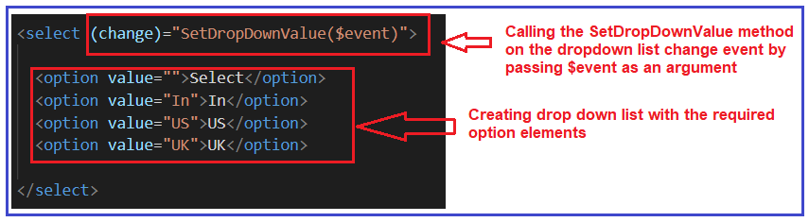

In the second step, we need to use the ngSwitch directive and in the ngSwitch directive, we need to bind the property (**dropDownValue**) and whose value is set by the drop-down list change event. Then we need to write the required ngSwitchCase statements. As we have three options in the drop-down list and so we have one ngSwitchCase one per each option value. Finally, we have the default switch case i.e. ngSwitchDefault which will execute when no options are selected from the dropdown list. For better understanding please have a look at the following image.

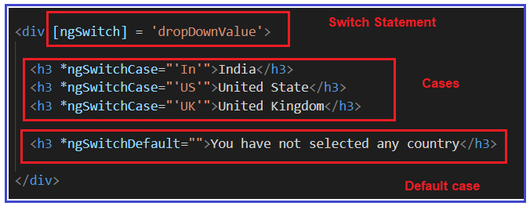

So, modify the **app.component.html** file as shown below and check in the browser and it should work as expected.

**<h2>**Select Country**</h2>**

**<select** (change)="SetDropDownValue($event)"**>**

**<option** value=""**>**Select**</option>**

**<option** value="In"**>**In**</option>**

**<option** value="US"**>**US**</option>**

**<option** value="UK"**>**UK**</option>**

**</select>**

**<h2>**You Have Selected**</h2>**

**<div** [ngSwitch] = 'dropDownValue'**>**

**<h3** *ngSwitchCase="'In'"**>**India**</h3>**

**<h3** *ngSwitchCase="'US'"**>**United State**</h3>**

**<h3** *ngSwitchCase="'UK'"**>**United Kingdom**</h3>**

**<h3** *ngSwitchDefault=""**>**You have not selected any country**</h3>**

**</div>**

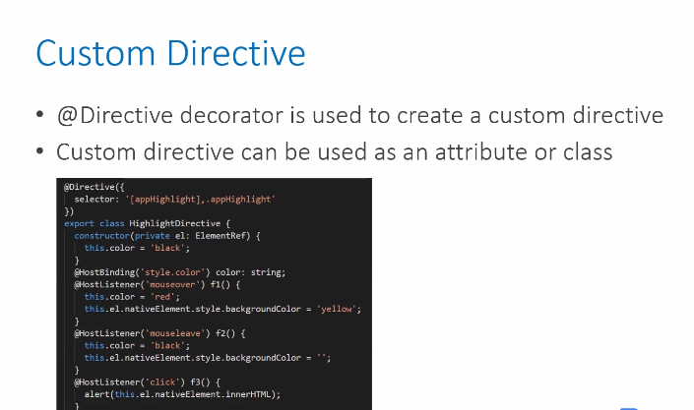

### How to Create Custom Directives?

We can create our custom directives to use in Angular components with the help of the command line. The command which is used to develop the Directive using the command

line is as follows-

The custom directive, or attribute directive, are responsible for modifying the appearance or behavior of HTML elements, just like we use properties along with any element’s properties.

By default, in Angular, there are two types of in-built attribute directives supported:

* **NgStyle** : This attribute directive is used to modify the appearance or behavior of the different DOM elements. It applies styles directly to the native element, such as font, font style, color, border, height, width, and so on.
* **NgClass** : This attribute directive is used to modify or apply the class attribute to the native DOM elements by just providing the class name along with the attribute name.

So far, we have learned about the custom directive and the type of attribute directive. Now we can also create the custom directive based on the business requirements, so let’s create it.

## Creating a Custom Directive using Angular CLI

The custom directive is nothing but the attribute directive, which allows us to change the behavior or appearance of an element by just providing the custom attribute and processing it.

In order to achieve this, we need to create a separate directive that gets the complete element, and we can process or modify it based on our requirements.

To create the custom directive, we can use Angular CLI. The command we need to execute is given below.

1Ng generate directive <directive_name>

shell

This is how we can create the directive by providing the directive name, for example.

1Ng generate directive mydirective

shell

## Example 1

Now let’s look at a simple example where we will create a custom directive to change the font color of the label control by using our newly generated custom directive.

For that, we need to use the below command to create the directive.

1Ng generate directive highlight

shell

After creating the directive, we need to import it into the module file. To do that, open **app.module.ts**, and the source code will look like this.:

1import { NgModule } from '@angular/core';

2import { BrowserModule } from '@angular/platform-browser';

3import { FormsModule } from '@angular/forms';

4import { AppComponent } from './app.component';

5

6// Importing the custom directive

7import { HighlightDirective } from './highlight.directive';

8

9@NgModule({

10 imports: [ BrowserModule, FormsModule ],

11 declarations: [ AppComponent, HighlightDirective ],

12 bootstrap: [ AppComponent ]

13})

14

15export class AppModule { }

typescript

Where the highlight is the name of our directive, and after executing the above command, the new file will be created, and the code will look like this:

### Highlight.directive.ts

1import { Directive } from '@angular/core';

2

3@Directive({

4 selector: '[appHighlight]'

5})

6

7export class HighlightDirective {

8 constructor() { }

9}

typescript

As we can see in the above example, the file contains the keyword @Directive(), which declares the directive with the selector appHighlight, which we can use into the template in order to change the behavior of the element.

The question may arise about how to access the element from the directive. Well, for that, we can use ElementRef, which allows us to access the element from the template directly, just like this:

1constructor(elementr: ElementRef) {

2 // can use elementr here to access the element properties

3}

typescript

Now let’s change the font color of a label element using the custom directive. Before that, open the file **app.component.html** and paste the following lines of code:

1<div>

2 <label appHighlight>This is label element</label>

3</div>

html

Notice that we have used appHighlight as an attribute along with the label element. This means we have used the custom attribute which accesses the current element, and by using ElementRef, we can modify its behavior.

Let’s jump to our newly created directive called **highlight.directive.ts** and replace the following source code.

1import { Directive, ElementRef } from "@angular/core";

2

3@Directive({

4 selector: "[appHighlight]"

5})

6

7export class HighlightDirective {

8

9 constructor(private el: ElementRef) {

10 // To change label's font color

11 el.nativeElement.style.color = "red";

12 }

13

14}

typescript

By using this directive, we wcan change the font color of the label. For that, we have accessed the native element using ElementRef, thus now we will be able to modify its styles just like we have modified the color of the element with the custom value.

When we run this example, the label control’s font color will be red based on our requirement.

In the same way, we can also modify the different attributes of the same elements with different values like this:

1export class HighlightDirective {

2

3 constructor(private el: ElementRef) {

4 // To change label's font color and other properties

5 el.nativeElement.style.color = "red";

6 el.nativeElement.style.fontWeight = "bolder";

7 el.nativeElement.style.border = "2px double black";

8 }

9

10}

typescript

This is just a simple example that shows how to access the native element using the custom directive and how to modify the styles of the element directly from the custom attribute. You can try this example on your own and observe the changes you get.

## Example 2

So far, we have seen how to create the directive using the Angular CLI and looked at a simple example to access and modify the styles of the element.

Now let’s jump to a more complex example where we will implement the directive which accepts the input value, and based on the length of the input value, we will change the background color of the input box directly from the custom directive.

Before digging into the example, we need to create a new custom directive. We can use the below command for that.

1Ng generate directive passwordlengthdetector

shell

We have created our custom directive so far, and now before using that directive, we need to import it into the module file like this.

1import { NgModule } from '@angular/core';

2import { BrowserModule } from '@angular/platform-browser';

3import { FormsModule } from '@angular/forms';

4import { AppComponent } from './app.component';

5import { PasswordlengthdetectorDirective } from './passwordlengthdetector.directive'

6

7@NgModule({

8 imports: [ BrowserModule, FormsModule ],

9 declarations: [ AppComponent, PasswordlengthdetectorDirective ],

10 bootstrap: [ AppComponent ]

11})

12

13export class AppModule { }

typescript

After creating the directive using the above command, we can see the newly created file like this:

### Passwordlengthdetector.directive.ts

1import { Directive } from '@angular/core';

2

3@Directive({

4 selector: '[appPasswordlengthdetector]'

5})

6

7export class PasswordlengthdetectorDirective {

8 constructor() { }

9

10}

typescript

So far, the basic configuration is done for our custom component. Now our requirement is to get the input value from the parent component and pass it to the directive for further processing. For that, let’s jump to the **app.component.html**, and the code will look like this.:

1<table>

2 <tr>

3 <td>

4 <label>Please enter your password :-</label>

5 </td>

6 <td>

7 <input type="text" appPasswordlengthdetector />

8 </td>

9 </tr>

10</table>

html

Here in this file, we have simple input control, but one thing to notice is that we have also used an additional attribute called appPasswordlengthdetector, which is our custom directive name. In this way, we are allowing our element to pass its value to the directive itself.

Let’s modify our custom directive so that it can change the behavior of the existing element based on our requirements.

### appPasswordlengthdetector.directive.ts

1import {

2 Directive,

3 ElementRef,

4 OnChanges,

5 HostListener

6} from "@angular/core";

7

8@Directive({

9 selector: "[appPasswordlengthdetector]"

10})

11

12export class PasswordlengthdetectorDirective implements OnChanges {

13

14 constructor(private el: ElementRef) {

15 console.log(el.nativeElement.value);

16 }

17

18 // Listen for keyup event and change background color

19 @HostListener("window:keyup") ngOnChanges(event) {

20

21 let count = this.el.nativeElement.value.length

22 console.log(this.el.nativeElement.value.length);

23 if(count < 5) {

24 this.el.nativeElement.style.backgroundColor = 'red'

25 } else if(count >= 5 && count <= 10) {

26 this.el.nativeElement.style.backgroundColor = 'green'

27 } else if(count > 10) {

28 this.el.nativeElement.style.backgroundColor = 'purple'

29 }

30

31 }

32

33}

typescript

Let's break down the code step by step to understand.

* The first step was to use the ElementRef so that we can access the current element from the template.
* Then we used HostListener, a decorator in Angular which is used to listen for the event attached to the host element. It will be destroyed once the directive is unmounted.
* Inside the HostListener event, we have accessed the native element using ElementRef’s object and will be modifying styles like backgroundcolor.

So when we change the input value based on the key up event, at that time, the value will be accessed from the directive, and the styles can be modified using the reference of the native element.

The background color will be changed based on the three conditions:

* Red if the length of password < 5
* Green if the length of password >=5 and <=10
* Purple if the length of password > 10

This is how we have created our very own custom directive that accepts the input value and is based on the length of the same value. It will change the input’s background color to denote the strength of the password.

## Conclusion

Custom directives are pretty handy when it comes to accessing inputs or elements and modifying their behavior and appearance.

In this guide, we got a basic introduction to custom directives, which are also called attribute directives, and the different types of directives are supported in Angular. We also looked at two different real-life examples that showed how to use custom directives into our Angular application. I hope you enjoyed this guide. Keep reading for more advanced guides in the future.

19

* [Features](https://help.pluralsight.com/help/using-pluralsight)

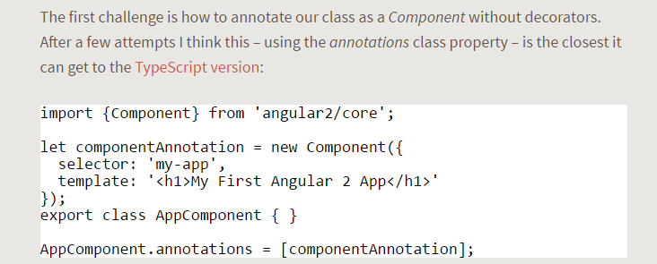

## Custom Directive

To create attribute directives, we always need to use or inject the below objects in our custom attribute directive component class. To create an attribute directive, we need to remember the below topics:

1. Import required modules like directives, ElementRef, and renderer from the Angular core library.
2. Create a TypeScript class.
3. Use the @Directive decorator in the class.
4. Set the value of the selector property in the @directive decorator function. The directive will be used, using the selector value on the elements.
5. In the constructor of the class, inject ElementRef and the renderer object.
6. You need to inject ElementRef in the directive’s constructor to access the DOM element
7. You need to call the renderer’s setElementStyle function. In this function, we need to pass the instance of the current DOM element with the help of ElementRef as a parameter and setting the behavior or property of the current element.

**ElementRef**- While creating a custom attribute directive, we inject ElementRef in the constructor to access the DOM element. ElementRef provides access to the underlying native element. With the help of ElementRef, we can obtain direct access to the DOM element using its nativeElement property. In that case, ElementRef is behaving just like a service. That’s all we need to set the element’s color using the browser DOM API.

**HostListener** — Sometimes we may need to access the input property within the attribute directive so that, as per the given attribute directive, we can apply a related attribute within the DOM Element. To trap user actions, we can call different methods to handle user actions. We need to use this method to perform any user action. For that purpose, we need to decorate the method with @HostListener method.

**Custom Attribute Directive Demo with mouse events**

First, we need to create our Directive class and register it to our app.module.ts.

import { Directive, OnInit } from '@angular/core';  
  
@Directive({  
 selector: '[appHighlight]'  
})  
export class HighlightDirectiveimplements OnInit {  
 constructor() {}  
  
 ngOnInit() {}  
}

An Angular Directive is essentially a component without a template. The behavior defined our Directive class will be applied to the host element.



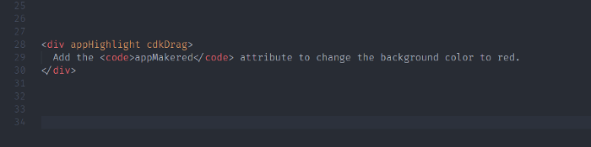

The Host Element in the markup above is our HTML div. The first thing we want to do is listen to when the Host Element is clicked. So let’s add the following code to our directive.

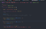

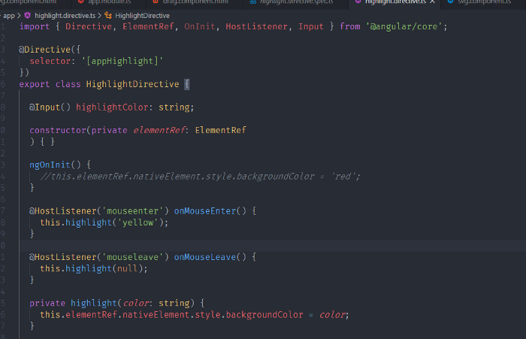

In our example above we are using an Angular decorator called @HostListener. This decorator allows you to listen to events on the Host Element easily. In our example, the first HostListner is mouseenter and The second p HostListner is mouseleave .



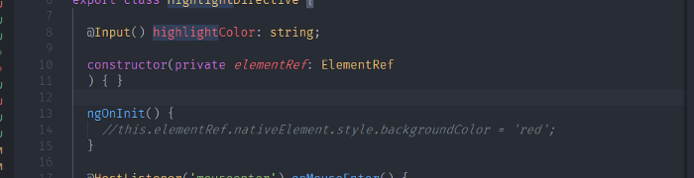

get a handle to the DOM element via ElementRef by injecting it into our component's constructor.



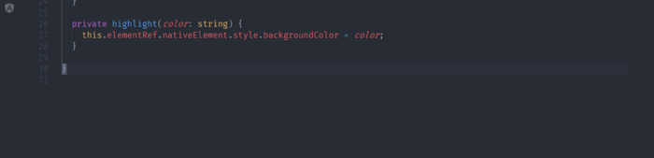

The ElementRef class defines a single property, nativeElement, which returns the object used by the browser to represent the element in the Domain Object Model. This object provides access to the methods and properties that manipulate the element

the final result is look like 👇

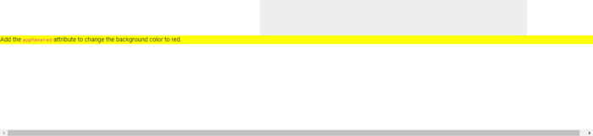

1. **What are Angular Pipes?**
2. **When and how to use Pipes in Angular Application?**
3. **Different types of Pipes with examples.**

##### **Why we need Angular Pipes?**

As we already know every web application starts with a simple task: first get the data, then transform the data into some format, and finally, show the formatted data to the users.

Getting the data is very simple, you can create a local variable or a complex type to hold the data or even you may get the data from APIs.

Once you get the data, then you could show the raw data as it is to the end-user, but that will not make a good user experience.

To get a good user experience we need to modify the raw data into some specific format and in such cases, Angular Pipes plays an important role.

##### **What are Pipes in Angular Application?**

The Angular Pipe takes the raw data as input and then transforms the raw data into some desired format. So in simple words, we can say that the angular pipes transform the data into a specific format before displaying them to the end-users.

Using the Pipe (|) operator, this can be used by the key above the enter key in our keyboard

we can apply the pipes features to any of the property in angular application. There are so many built-in pipes provides by Angular Framework such as

* lowercase,
* uppercase,
* titlecase,
* decimal,
* date,
* percent,
* currency etc. It is also possible to create custom pipes.

###### **Syntax to use Pipes in Angular Application:**

Syntaxes are written inside the HTML. The syntax to use the Angular Pipe is given below. To apply a pipe on a property, you need to use the pipe operator “|”.

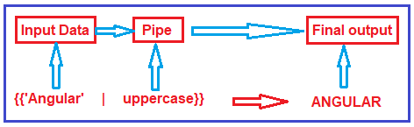

##### **Types of Pipes in Angular:**

The Angular Framework divided the Pipes into two types i.e. Built-in Pipes and Custom Pipes. Further Built-in Pipes are divided into two types i.e. Parameterized and chaining as shown in the below image.

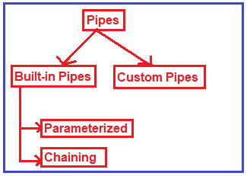

##### **Example to understand Angular Pipes:**

Let us see an example to understand pipes. First we will see the output without pipes and then we will see the output with pipes.

##### **Modify app.component.ts file:**

Please modify the app.component.ts file as shown below. Here, we have created one student array with some dummy data that we want to show in the web page.

**import** **{** Component **}** from '@angular/core';

@Component**({**

selector: 'app-root',

templateUrl: './app.component.html',

styleUrls: **[**'./app.component.css'**]**

**})**

**export** **class** AppComponent **{**

students: **any[]** = **[**

**{**

ID: 'std101', Name: 'RaKesh ROUT',

DOB: '12/8/1988', Gender: 'Male', CourseFee: 1234.56

**}**,

**{**

ID: 'std102', Name: 'ANURAG Mohanty',

DOB: '10/14/1989', Gender: 'Male', CourseFee: 6666.00

**}**,

**{**

ID: 'std103', Name: 'Priyanka Dewangan',

DOB: '7/24/1992', Gender: 'Female', CourseFee: 6543.15

**}**,

**{**

ID: 'std104', Name: 'Hina SHARMA',

DOB: '8/19/1990', Gender: 'Female', CourseFee: 9000.50

**}**,

**{**

ID: 'std105', Name: 'SamBIt SataPATHY',

DOB: '4/12/1991', Gender: 'Male', CourseFee: 9876.54

**}**

**]**;

**}**

##### **Modify app.component.html file:**

Please modify **app.component.html**file as shown below. As you can see at the moment we are not using any pipes.

**<table** border="1"**>**

**<thead>**

**<tr>**

**<th>**Student ID**</th>**

**<th>**Name**</th>**

**<th>**DOB**</th>**

**<th>**Gender**</th>**

**<th>**Course Fee**</th>**

**</tr>**

**</thead>**

**<tbody>**

**<tr** *ngFor='let student of students'**>**

**<td>**{{student.ID}}**</td>**

**<td>**{{student.Name}}**</td>**

**<td>**{{student.DOB}}**</td>**

**<td>**{{student.Gender}}**</td>**

**<td>**{{student.CourseFee}}**</td>**

**</tr>**

**</tbody>**

**</table>**

Now, if you browse the application, then you will get the following output in the browser.

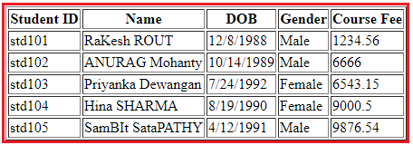

As you can see in the above image, the data is not that user friendly. Let us discuss how we want to display the above data. We want to display the Student ID in upper case character and Name using the title case i.e. first character of every word in uppercase. Again, we want to display display the Date of Birth in **MM/DD/YYYY** format. We can achieve this by using the date pipe. Again we want to display the Gender in lower case and finally, we want to display the course Fee using the $ sign as shown in the below image.

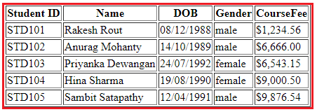

##### **How can we achieve the above output?**

In order to achieve the desired output, we are going to use the following built-in pipes.

1. **lowercase**: This is used to convert the characters into lower case.
2. **uppercase**: This is used to convert the characters into upper case.
3. **titlecase**: This built-in pipe is used to convert the first character in each word to upper case.
4. **date**: This pipe is used to convert a date to some specific format.
5. **currency**: this pipe is used to convert number to currency with currency symbol.

So, modify the **app.component.html** file as shown below to use the required built-in pipes to get the desired output.

**<table** border="1"**>**

**<thead>**

**<tr>**

**<th>**Student ID**</th>**

**<th>**Name**</th>**

**<th>**DOB**</th>**

**<th>**Gender**</th>**

**<th>**CourseFee**</th>**

**</tr>**

**</thead>**

**<tbody>**

**<tr** *ngFor='let student of students'**>**

**<td>**{{student.ID | uppercase}}**</td>**

**<td>**{{student.Name | titlecase}}**</td>**

**<td>**{{student.DOB | date:'dd/MM/yyyy'}}**</td>**

**<td>**{{student.Gender | lowercase}}**</td>**

**<td>**{{student.CourseFee | currency:'USD':true}}**</td>**

**</tr>**

**</tbody>**

**</table>**

Now, run the application and you should get the output as expected.

## ****Creating Angular Custom Pipe****

In this article, I am going to discuss **how to create Angular Custom Pipe** with an example. Please read our previous article before proceeding to this article where we discussed the [**Built-in Angular Pipes**](https://dotnettutorials.net/lesson/angular-parameterized-pipes/). At the end of this article, you will understand how to create custom pipe and when do we need to create custom pipes and how to use it in Angular Application.

##### **Let us understand the need of Angular Custom Pipe with an example.**

Suppose you want to display the students detail in a web page. So, let us first create the student data in the AppComponent.

##### **Modify app.component.ts file:**

Open **app.component.ts** file and then copy and paste the following code in it. As you can here we simply created an student array.

**import** **{** Component **}** from '@angular/core';

@Component**({**

selector: 'app-root',

templateUrl: './app.component.html',

styleUrls: **[**'./app.component.css'**]**

**})**

**export** **class** AppComponent **{**

students: **any[]** = **[**

**{**

ID: 'std101', Name: 'Rakesh Rout',

DOB: '12/8/1988', Gender: 'Male', CourseFee: 1234.56

**}**,

**{**

ID: 'std102', Name: 'Anurag Mohanty',

DOB: '10/14/1989', Gender: 'Male', CourseFee: 6666.00

**}**,

**{**

ID: 'std103', Name: 'Priyanka Dewangan',

DOB: '7/24/1992', Gender: 'Female', CourseFee: 6543.15

**}**,

**{**

ID: 'std104', Name: 'Hina Sharma',

DOB: '8/19/1990', Gender: 'Female', CourseFee: 9000.50

**}**,

**{**

ID: 'std105', Name: 'Sambit Satapathy',

DOB: '4/12/1991', Gender: 'Male', CourseFee: 9876.54

**}**

**]**;

**}**

Let us show these student data in the web page.

##### **Modify app.student.html file:**

Open app.student.html file and then copy and paste the following code in it. As you can here we have applied some built-in pipes to format the data.

**<table** border="1"**>**

**<thead>**

**<tr>**

**<th>**Student ID**</th>**

**<th>**Name**</th>**

**<th>**DOB**</th>**

**<th>**Gender**</th>**

**<th>**CourseFee**</th>**

**</tr>**

**</thead>**

**<tbody>**

**<tr** *ngFor='let student of students'**>**

**<td>**{{student.ID | uppercase}}**</td>**

**<td>**{{student.Name }}**</td>**

**<td>**{{student.DOB | date:'dd/MM/yyyy'}}**</td>**

**<td>**{{student.Gender | lowercase}}**</td>**

**<td>**{{student.CourseFee | currency:'USD':true}}**</td>**

**</tr>**

**</tbody>**

**</table>**

At this moment if you run the application, then you will get the following output in the browser.

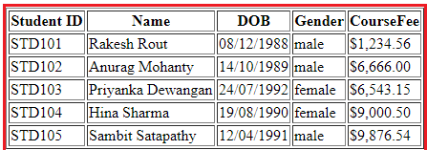

Now, the requirement changes, now they want to show the title depending on the gender of the student I.e. we need to add Mr. or Miss. prefixed before the name of the student as shown in the below image.

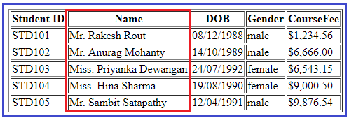

##### **How we can achieve this?**

We can achieve this very easily by creating an angular custom pipe.

##### **How to create Angular Custom Pipe?**

In order to create a custom pipe in angular, you have to apply the @Pipe decorator to a class which you can import from the Angular Core Library. The @Pipe decorator allows you to define the pipe name that you will use within the template expressions. The syntax to create a pipe in angular is given below.

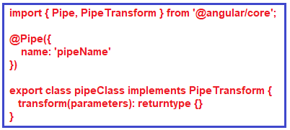

**Note:**The transform method will decide the input types, the number of parameters and the output type.

##### **Creating Angular Custom Pipe using Angular CLI:**

Let say we want to create a custom pipe with the name MyTitle. In order to create a custom MyTitle pipe open a new terminal and type **ng g pipe MyTitle –flat** and press enter as shown in the below image.

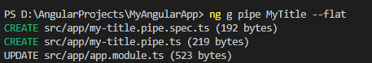

Once you type **ng g pipe MyTitle –flat** and press enter, it will take some time and create two files (**my-title.pipe.ts** and **my-title.pipe.spec.ts**) within the app folder. Along the way, it also update the app.module.ts file.

##### **Modify my-title.pipe.ts file:**

Now, open my-title.pipe.ts file and then copy and paste the following code in it.

**import** **{** Pipe, PipeTransform **}** from '@angular/core';

@Pipe**({**

name: 'myTitle'

**})**

**export** **class** MyTitlePipe implements PipeTransform **{**

transform**(**name: **string**, gender: **string)**: **string** **{**

**if** **(**gender.toLowerCase**()** == "male"**)**

**return** "Mr. " + name;

**else**

**return** "Miss. " + name;

**}**

**}**

##### **Understanding above code:**

1. First, we import the **Pipe**decorator and **PipeTransform**interface from the Angular core Library.
2. Then we decorated the “**MyTitlePipe**” class with the **Pipe**decorator so that this class will become an Angular pipe.
3. We then set the name property of the pipe decorator to **myTitle**so that we can use this name (myTitle) on any HTML page where we want this pipe functionality.
4. The **MyTitlePipe**class implements the **PipeTransform**interface and that interface has one method called **transform**() and here we implement that method.
5. As you can see in the above code, the **transform**method takes 2 parameters (name and gender). The name parameter will receive the name of the student whereas the gender parameter will receive the gender of the student. The method returns a string i.e. Mr. or Miss. prefixed to the name of the student depending on their gender.

##### **Registering the Custom Pipe in Angular Application:**

Before using the custom MyTitlePipe, first we need to register it in the app.module.ts file. If you are creating it using Angular CLI, then the angular framework will automatically register the pipe. To make sure, let us modify the app.module.ts file as shown below. Here, first we need to import the MyTitlePipe and then we need to include it in the “declarations” array of NgModule decorator.

**import** **{** BrowserModule **}** from '@angular/platform-browser';

**import** **{** NgModule **}** from '@angular/core';

**import** **{** FormsModule **}** from '@angular/forms';

**import** **{** AppRoutingModule **}** from './app-routing.module';

**import** **{** AppComponent **}** from './app.component';

**import** **{** MyTitlePipe **}** from './my-title.pipe';

@NgModule**({**

declarations: **[**

AppComponent,

MyTitlePipe,

**]**,

imports: **[**

BrowserModule,

AppRoutingModule,

FormsModule

**]**,

providers: **[]**,

bootstrap: **[**AppComponent**]**

**})**

**export** **class** AppModule **{** **}**

##### **Using the Custom Pipe in Angular Application:**

Modify the **app.component.html** file as shown below. Notice that we are passing the student gender as an argument for the gender parameter to our custom pipe. The Student name gets passed automatically.

**<table** border="1"**>**

**<thead>**

**<tr>**

**<th>**Student ID**</th>**

**<th>**Name**</th>**

**<th>**DOB**</th>**

**<th>**Gender**</th>**

**<th>**CourseFee**</th>**

**</tr>**

**</thead>**

**<tbody>**

**<tr** *ngFor='let student of students'**>**

**<td>**{{student.ID | uppercase}}**</td>**

**<td>**{{student.Name | myTitle:student.Gender}}**</td>**

**<td>**{{student.DOB | date:'dd/MM/yyyy'}}**</td>**

**<td>**{{student.Gender | lowercase}}**</td>**

**<td>**{{student.CourseFee | currency:'USD':true}}**</td>**

**</tr>**

**</tbody>**

**</table>**

With the above changes in place, now run the application and you should the output as expected.

DECORATORS

A deep dive on Angular decorators

*JAN 26, 2017 -*[*Edit this page on GitHub*](https://github.com/toddmotto/toddmotto.github.io/blob/master/_posts/2017-01-26-angular-decorators.md)

[90% Unlimited Downloads Choose from Over 300,000 Vectors, Graphics & Photos.](https://www.graphicstock.com/join/browse?utm_campaign=AFFGS-BSACPA-affiliate-site1-joinbrowse&utm_medium=affiliate&utm_source=AFFGS-BSACPA-affiliate-site1-joinbrowse)ads via [Carbon](http://carbonads.com/)

Decorators are a core concept when developing with Angular (versions 2 and above). There’s also an official [TC39 proposal](https://github.com/tc39/proposal-decorators), currently at Stage-2, so expect decorators to become a core language feature soon in JavaScript as well.Back to Angular, the internal codebase uses decorators extensively and in this post we’re going to look at the different types of decorators, the code they compile to and how they work.When I was first introduced to TypeScript and decorators, I wondered why we needed them at all, but once you dig a little deeper you can understand the benefits to creating decorators (not only for use in Angular).AngularJS didn’t use decorators, opting for a different registration method - such as defining a component for example with the .component() method. So why has Angular chose to use them? Let’s explore.

[Table of contents](https://toddmotto.com/angular-decorators#table-of-contents)

* [Angular Decorators](https://toddmotto.com/angular-decorators#angular-decorators)
  + [Class Decorators](https://toddmotto.com/angular-decorators#class-decorators)
  + [Property Decorators](https://toddmotto.com/angular-decorators#property-decorators)
  + [Method Decorators](https://toddmotto.com/angular-decorators#method-decorators)
  + [Parameter Decorators](https://toddmotto.com/angular-decorators#parameter-decorators)
* [Creating a decorator](https://toddmotto.com/angular-decorators#creating-a-decorator)
  + [Decorator Functions](https://toddmotto.com/angular-decorators#decorator-functions)
  + [Passing data to a decorator](https://toddmotto.com/angular-decorators#passing-data-to-a-decorator)
* [What Angular decorators actually do](https://toddmotto.com/angular-decorators#what-angular-decorators-actually-do)
  + [Storing metadata](https://toddmotto.com/angular-decorators#storing-metadata)
  + [Chaining decorators](https://toddmotto.com/angular-decorators#chaining-decorators)
* [How decorators are applied](https://toddmotto.com/angular-decorators#how-decorators-are-applied)
* [Summary](https://toddmotto.com/angular-decorators#summary)

[Angular Decorators](https://toddmotto.com/angular-decorators#angular-decorators)

Before we look at creating a custom decorator and why/how Angular uses them, let’s look at the different types of decorators that Angular offers. There are 4 main types:

* Class decorators, e.g. @Component and @NgModule
* Property decorators for properties inside classes, e.g. @Input and @Output
* Method decorators for methods inside classes, e.g. @HostListener
* Parameter decorators for parameters inside class constructors, e.g. @Inject.Each decorator has a unique role, let’s jump to some examples to expand on the list above.
* [Class Decorators](https://toddmotto.com/angular-decorators#class-decorators):
* Angular offers us a few class decorators. These are the top-level decorators that we use to express *intent* for classes. They allow us to tell Angular that a particular class is a component, or module, for example. And the decorator allows us to define this intent without having to actually put any code inside the class.A @Component and @NgModule decorator example with classes:

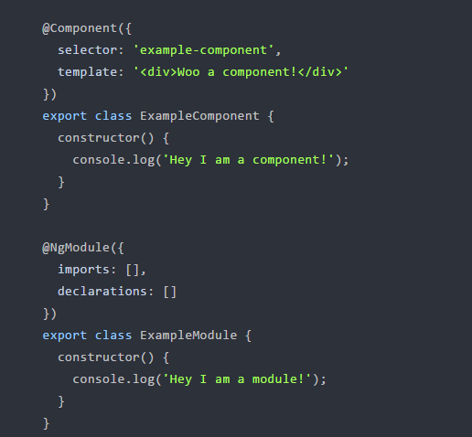asses by themselves are effectively the same. No code is needed within the class to tell Angular that it is a component or a module. All we need to do is decorate it, and Angular will do the rest.

[Property Decorators](https://toddmotto.com/angular-decorators#property-decorators):These are probably the second most common decorators that you’ll come across. They allow us to decorate specific properties within our classes - an extremely powerful mechanism.Let’s take a look at **@Input().** Imagine that we have a property within our class that we want to be an input binding.Without decorators, we’d have to define this property in our class anyway for TypeScript to know about it, and then somewhere else tell Angular that we’ve got a property that we want to be an input.With decorators, we can simply put the @Input() decorator above the property - which Angular’s compiler will automatically create an input binding from the property name and link them.

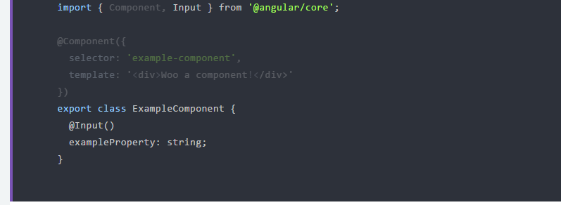

We’d then pass the input binding via a component property binding:

<example-component

[exampleProperty]="exampleData">

</example-component>

The property decorator and “magic” happens *within* the ExampleComponentdefinition.

In AngularJS 1.x (I’m going to use TypeScript here also, just to declare a property on a class), we had a different mechanism using scope or bindToController with Directives, and bindings within the new [component method](https://toddmotto.com/exploring-the-angular-1-5-component-method/):

const exampleComponent = {

bindings: {

exampleProperty: '<'

},

template: `

<div>Woo a component!</div>

`,

controller: class ExampleComponent {

exampleProperty: string;

$onInit() {

// access this.exampleProperty

}

}

};

angular

.module('app')

.component('exampleComponent', exampleComponent);

You can see above that we have two separate properties to maintain should we expand, refactor or change our component’s API - bindings and the property name inside the class. However, in Angular there is a single property examplePropertywhich is decorated, which is easier to change, maintain and track as our codebase grows.

[Method Decorators](https://toddmotto.com/angular-decorators#method-decorators)

Method decorators are very similar to property decorators but are used for methods instead. This let’s us decorate specific methods within our class with functionality. A good example of this is @HostListener. This allows us to tell Angular that when an event on our host happens, we want the decorated method to be called with the event.

import { Component, HostListener } from '@angular/core';

@Component({

selector: 'example-component',

template: '<div>Woo a component!</div>'

})

export class ExampleComponent {

@HostListener('click', ['$event'])

onHostClick(event: Event) {

// clicked, `event` available

}

}

[Parameter Decorators](https://toddmotto.com/angular-decorators#parameter-decorators)

Parameter decorators are quite interesting. You may have come across these when injecting primitives into a constructor, where you need to manually tell Angular to inject a particular provider.

For a deep dig into Dependency Injection (DI), tokens, @Inject and @Injectable, check out [my previous article](https://toddmotto.com/angular-dependency-injection).

Parameter decorators allow us to decorate parameters in our class constructors. An example of this is @Inject that lets us tell Angular what we want that parameter to be initiated with:

import { Component, Inject } from '@angular/core';

import { MyService } from './my-service';

@Component({

selector: 'example-component',

template: '<div>Woo a component!</div>'

})

export class ExampleComponent {

constructor(@Inject(MyService) myService) {

console.log(myService); // MyService

}

}

Due to the metadata that TypeScript exposes for us we don’t actually have to do this for our providers. We can just allow TypeScript and Angular to do the hard work for us by specifying the provider to be injected as the parameter *type*:

import { Component } from '@angular/core';

import { MyService } from './my-service';

@Component({

selector: 'example-component',

template: '<div>Woo a component!</div>'

})

export class ExampleComponent {

constructor(myService: MyService) {

console.log(myService); // MyService

}

}

Now that we’ve covered the types of decorators we can use, let’s dig into what they actually are doing - and why we need them.

[Creating a decorator](https://toddmotto.com/angular-decorators#creating-a-decorator)

It makes things a lot easier if we understand what a decorator is actually doing before we look into how Angular uses them under the hood. To do this, we can create a quick example decorator.

[Decorator functions](https://toddmotto.com/angular-decorators#decorator-functions)

Decorators are actually just functions, it’s as simple as that, and are called with whatever they are decorating. A method decorator will be called with the value of the method it’s decorating, and a class decorator will be called with the class to be decorated.

Let’s quickly make a decorator that we can use on a class to demonstrate this a little further. This decorator is just going to simply log the class to the console:

function Console(target) {

console.log('Our decorated class', target);

}

Here, we have created Console (using the uppercase naming convention Angular uses) and are specifying a single argument called target. The target will in fact be the class that we decorate, which means we can now decorate any class with our decorator and see it outputted in the console:

@Console

class ExampleClass {

constructor() {

console.log('Yo!');

}

}

Want to see it in action? Check out the [live demo](https://jsfiddle.net/toddmotto/kunm0xm3/).

[Passing data to a decorator](https://toddmotto.com/angular-decorators#passing-data-to-a-decorator)

When we use the decorators in Angular we pass in some form of configuration, specific to the decorator.

For example, when we use @Component we pass through an object, and with @HostListener we pass through a string as the first argument (the event name, such as 'click') and optionally an array of strings for further variables (such as $event) to be passed through to the decorated method.

Let’s change our code above to execute the Console function with a value to match how we use the Angular decorators.

@Console('Hey!')

class ExampleClass {

constructor() {

console.log('Yo!');

}

}

If we ran this code now, we’d only get 'Hey!' outputted to the console. That’s because our decorator hasn’t returned a function for the class to be given to. The output of @Console('Hey!') is void.

We would need to adapt our Console decorator to return a function closure for the class to be given to. That way we can both receive a value from the decorator (in our case, the string Hey!) and also the class that it’s applied to:

function Console(message) {

// access the "metadata" message

console.log(message);

// return a function closure, which

// is passed the class as `target`

return function (target) {

console.log('Our decorated class', target);

}

}

@Console('Hey!')

class ExampleClass {

constructor() {

console.log('Yo!');

}

}

// console output: 'Hey!'

// console output: 'Our decorated class', class ExampleClass{}...

You can see the [changes here](https://jsfiddle.net/toddmotto/qaqeapn6/).This is the basis for how the decorators in Angular work. They first of all take a configuration value and then receive the class/method/property to apply the decoration to. Now that we have a brief understanding of what a decorator actually does, we’re going to walk through how Angular creates and uses it’s own decorators.

[What Angular decorators actually do](https://toddmotto.com/angular-decorators#what-angular-decorators-actually-do)

Every type of decorator shares the same core functionality. From a purely decorative point of view, @Component and @Directive both work in the same way, as do @Input and @Output. Angular does this by using a factory for each type of decorator.

Let’s look at the most common decorator in Angular, the @Component.

We’re not going to dive into the *actual* code that Angular uses to create these decorators because we only need to understand them on a higher level.

[Storing metadata](https://toddmotto.com/angular-decorators#storing-metadata)

The whole point of a decorator is to store metadata about a class, method or property as we’ve already explored. When you configure a component for example, you’re providing metadata for that class that tells Angular that we have a component, and that component has a specific configuration.

Each decorator has a base configuration that you can provide for it, with some defaults applied for you. When the decorator is created using the relevant factory, the default configuration is passed through. For instance, let’s take a look at the possible configuration that you can use when creating a component:

{

selector: undefined,

inputs: undefined,

outputs: undefined,

host: undefined,

exportAs: undefined,

moduleId: undefined,

providers: undefined,

viewProviders: undefined,

changeDetection: ChangeDetectionStrategy.Default,

queries: undefined,

templateUrl: undefined,

template: undefined,

styleUrls: undefined,

styles: undefined,

animations: undefined,

encapsulation: undefined,

interpolation: undefined,

entryComponents: undefined

}

There are a lot of different options here, and you’ll notice that only one has a default value - changeDetection. This is specified when the decorator is created so we don’t need to add it whenever we create a component. You may have applied this line of code to modify the change strategy:

changeDetection: ChangeDetectionStrategy.OnPush

An annotation instance is created when you use a decorator. This merges the default configuration for that decorator (for instance the object you see above) with the configuration that you have specified, for example:

import { NgModule, Component } from '@angular/core';

@Component({

selector: 'example-component',

styleUrls: ['example.component.scss'],

template: '<div>Woo a component!</div>'

})

export class ExampleComponent {

constructor() {

console.log('Hey I am a component!');

}

}

Would create an annotation instance with the properties of:

{

selector: 'example-component',

inputs: undefined,

outputs: undefined,

host: undefined,

exportAs: undefined,

moduleId: undefined,

providers: undefined,

viewProviders: undefined,

changeDetection: ChangeDetectionStrategy.Default,

queries: undefined,

templateUrl: undefined,

template: '<div>Woo a component!</div>',

styleUrls: ['example.component.scss'],

styles: undefined,

animations: undefined,

encapsulation: undefined,

interpolation: undefined,

entryComponents: undefined

}

Once this annotation instance has been created it is then stored so Angular can access it.

[Chaining decorators](https://toddmotto.com/angular-decorators#chaining-decorators)

If a decorator is used on a class for the first time, it creates a new array and pushes the annotation instance into it. If this isn’t the first decorator that has been used on the class, it pushes it into the existing annotation array. This allows decorators to be chained together and all stored in one place.

For example, in Angular you could do this for a property inside a class:

export class TestComponent {

@Input()

@HostListener('click', ['$event'])

onClick: Function;

}

At the same time, Angular also uses the reflect API (commonly polyfilled using reflect-metadata) to store these annotations, using the class as an array. This means that it can then later on fetch all of the annotations for a specific class just by being pointed to the class.

[How decorators are applied](https://toddmotto.com/angular-decorators#how-decorators-are-applied)

So we know now how and why Angular uses decorators, but how are they actually applied to a class?

As mentioned, decorators aren’t native to JavaScript just yet - TypeScript currently provides the functionality for us. This means that we can check the compiled code to see what actually happens when we use a decorator.

Take a standard, ES6 class -

class ExampleClass {

constructor() {

console.log('Yo!');

}

}

TypeScript will then convert this over to a function for us:

var ExampleClass = (function () {

function ExampleClass() {

console.log('Yo!');

}

return ExampleClass;

}());

Now, if we decorate our class, we can see where the decorators are then actually applied.

@ConsoleGroup('ExampleClass')

class ExampleClass {

constructor() {

console.log('Yo!');

}

}

TypeScript then outputs:

var ExampleClass = (function () {

function ExampleClass() {

console.log('Yo!');

}

return ExampleClass;

}());

ExampleClass = __decorate([

ConsoleGroup('ExampleClass')

], ExampleClass);

This gives us some actual context as to how our decorators are applied.

The __decorate call is a helper function that would be outputted at the top of our compiled file. All that this does is apply our decorators to our class, (calling ConsoleGroup('ExampleClass') with ExampleClass as the argument).

[Summary](https://toddmotto.com/angular-decorators#summary)

Demystifying decorators is one step into understanding some more of the Angular “magic” and how Angular uses them. They give Angular the ability to store metadata for classes and streamline our workflow simultaneously.